**A Project Report On**

**Blood Donation Management System**

DEVELOPED BY:

IT148 – OM UNADKAT IT155 – KUNJ VASOYA

IT159– DARPAN VORA

Guided By Internal Guide:

Prof. Shweta Jambukia

Department of Information Technology Faculty of Technology

DD University



**Department of Information Technology Faculty of Technology, Dharmsinh Desai University College Road, Nadiad-387001 March-2024**

# CERTIFICATE

This is to certify that the project entitled “Ed Tech Management ” is a bonafide report of the work carried out by

1. **OM UNADKAT** Student ID No: **22ITUOS023**
2. **KUNJ VASOYA** Student ID No: **22ITUOS019**
3. **DARPAN VORA** Student ID No: **22ITUOS005**

of Department of Information Technology, semester 4, under the guidance and supervision for the subject Database Management System. They were involved in Project training during the academic year 2023-24.

Prof. Shweta Jambukia

Project Guide, Department of Information Technology, Faculty of Technology,

Dharmsinh Desai University, Nadiad Date:13/3/2024

Prof. Vipul Dabhi

Head, Department of Information Technology

**INDEX**

1. Certificate I
2. Commendation II
   1. SYSTEM OVERVIEW 4
      1. Current system 4
      2. Advantages of the Proposed system (over current) 4

2.E-R Diagram 5

1. Relaition Schema 6
2. Data DICTIONARY 7
3. DATABASE IMPLEMENTATION 12
   1. Create Schema 12
   2. Insert Data values 15
   3. Queries……………………………..` 20
   4. Queries (Based on Joins & Sub-Queries) 20
   5. PL/SQL Blocks (Views) 25
   6. Functions & Triggers 26
   7. Cursors 30

## SYSTEM OVERVIEW

Data is the code word of the computer industry. Data refers to a collection of facts usually collected as a result of observation and experiment or processes within a computer system. This may consist of numbers, words or images or observations of a set of variables. Data are often viewed as a lowest level of abstraction from which information and knowledge are derived.

Ed tech management is a web based system that can assists the information of every student during its handling in the course . With this system, the user of this system can key in the result of test that has been conducted and received by the admin The result of test will indicated .

From this system, there are several type of report that can be generated such as certificates , Students' result of his test and the total of fee of the paid course according to months and year. The system also can give information to the user about analysis of test result for each time the student gives test Hence, BBMS will make the ED tech system more systematic and manageable.

## 1.3 ADVANTAGES OF THE PROPOSED SYSTEM

The given educational technology (EdTech) database offers several advantages:1. Centralized Data Management: The database centralizes information related to administrators, students, courses, tests, results, payments, feedback, and more. This centralized approach streamlines data management and ensures data integrity.2. Efficient Course Management: With tables like course, free_course, and paid_course, the database efficiently manages course details, including course ratings, stages, and durations. This allows for easy tracking and management of both free and paid courses.3. Comprehensive Testing System: The test and results tables facilitate a comprehensive testing system. Tests can be scheduled, conducted, and results recorded accurately. This aids in assessing student performance effectively.4. Feedback Analysis: The feedback table captures student feedback, enabling educators to analyze and address areas of improvement. This feedback loop fosters continuous improvement in course content and delivery.5. Certification Management: The certificate table manages certifications earned by students upon course completion. This feature adds value to the courses offered and enhances student

6. Diverse Payment Methods: The database supports various payment methods through tables like methods, UPI, DEBIT_CREDIT_CARDS, and Net_Banking1. This flexibility allows students to choose preferred payment methods, enhancing user experience.7. Resourceful Video Lectures: Video lectures are efficiently managed through the videolec table, including details such as duration and tutor. This resourceful feature supports multimedia learning and enriches the educational experience.8. Secure Payment Handling: With tables like payment and associated payment method tables, the database ensures secure handling of payment transactions. This security instills trust among students regarding financial transactions.9. Convenient User Interaction: The database design facilitates smooth interactions between students, administrators, and educators. Each entity has well-defined relationships and roles, promoting effective communication and collaboration.10. Scalability and Adaptability: The database structure is designed to accommodate future growth and changes in educational offerings. Its scalability and adaptability make it suitable for evolving educational needs and technological advancements..

**2. ENTITY-RELATIONSHIP MODEL**

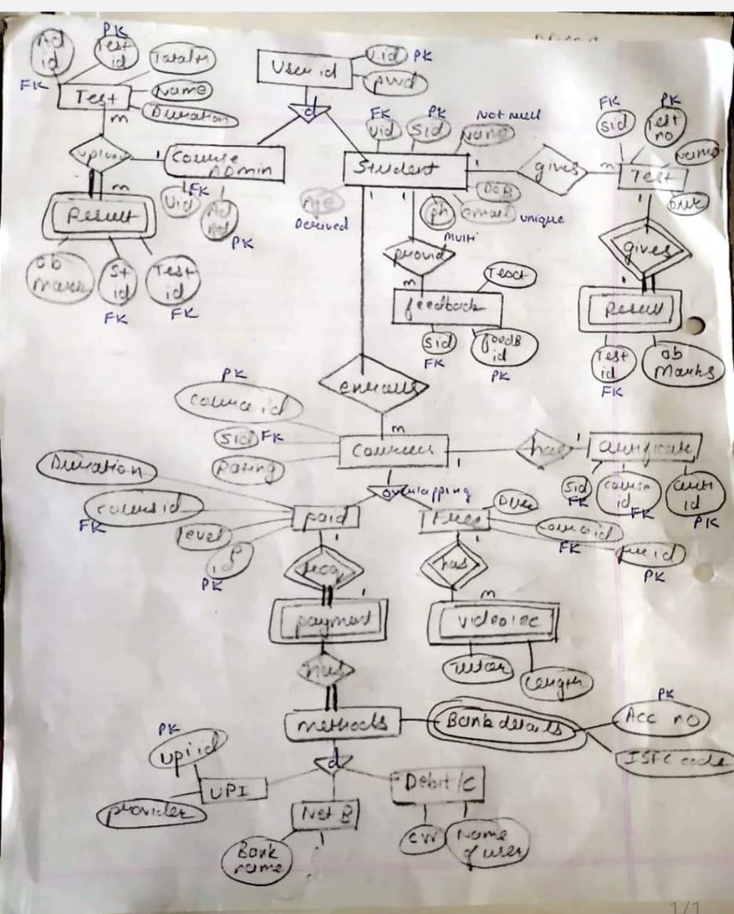

# RELATIONAL SCHEMA

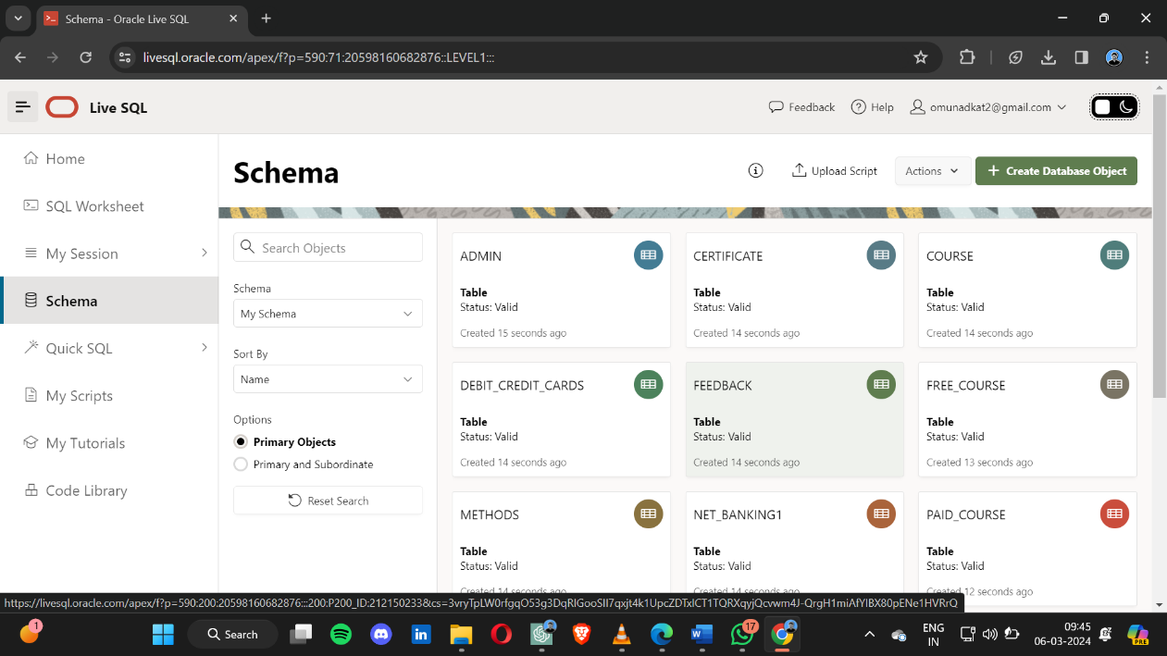

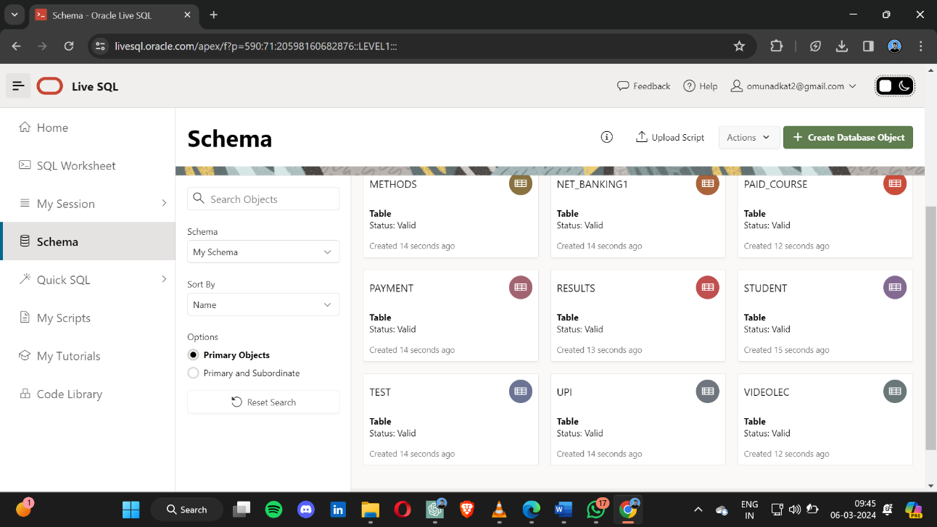

1. **Data Dictionary**
   1. Admin

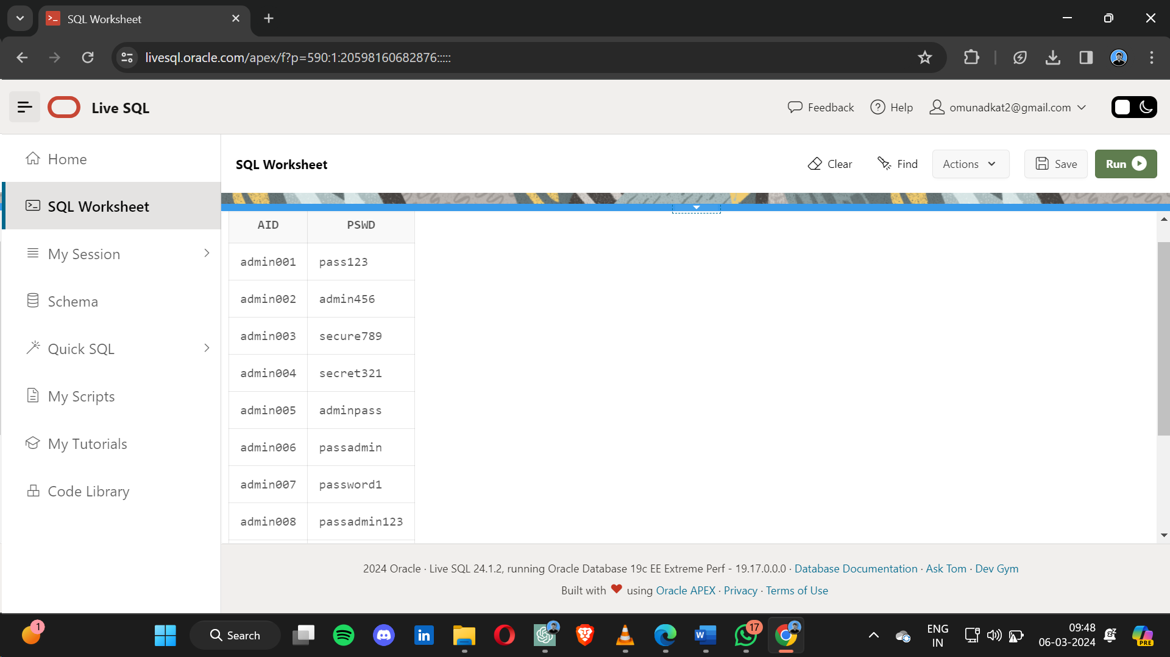

* 1. Students

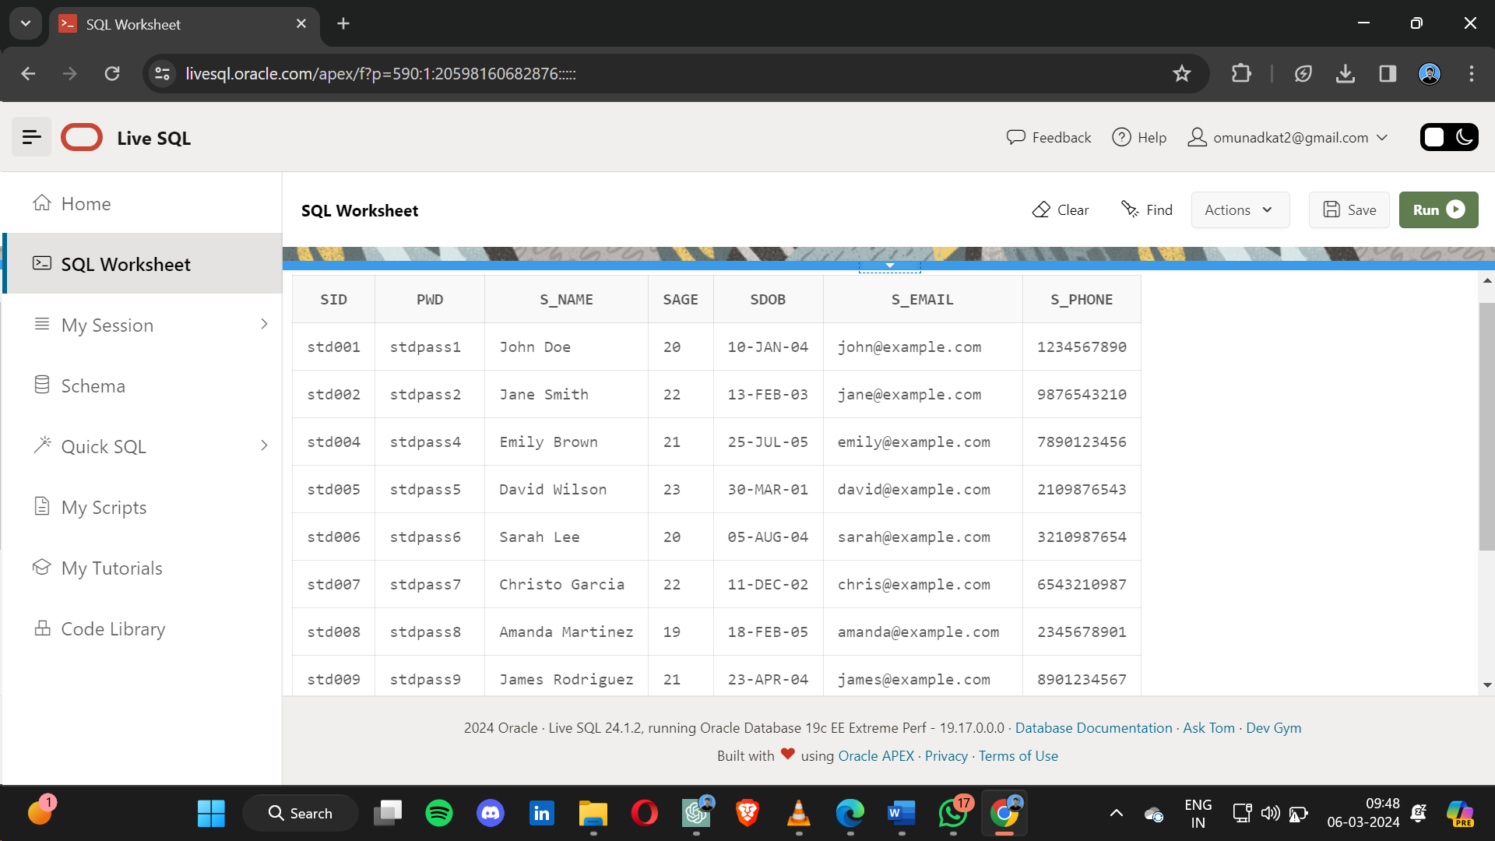

* 1. Test

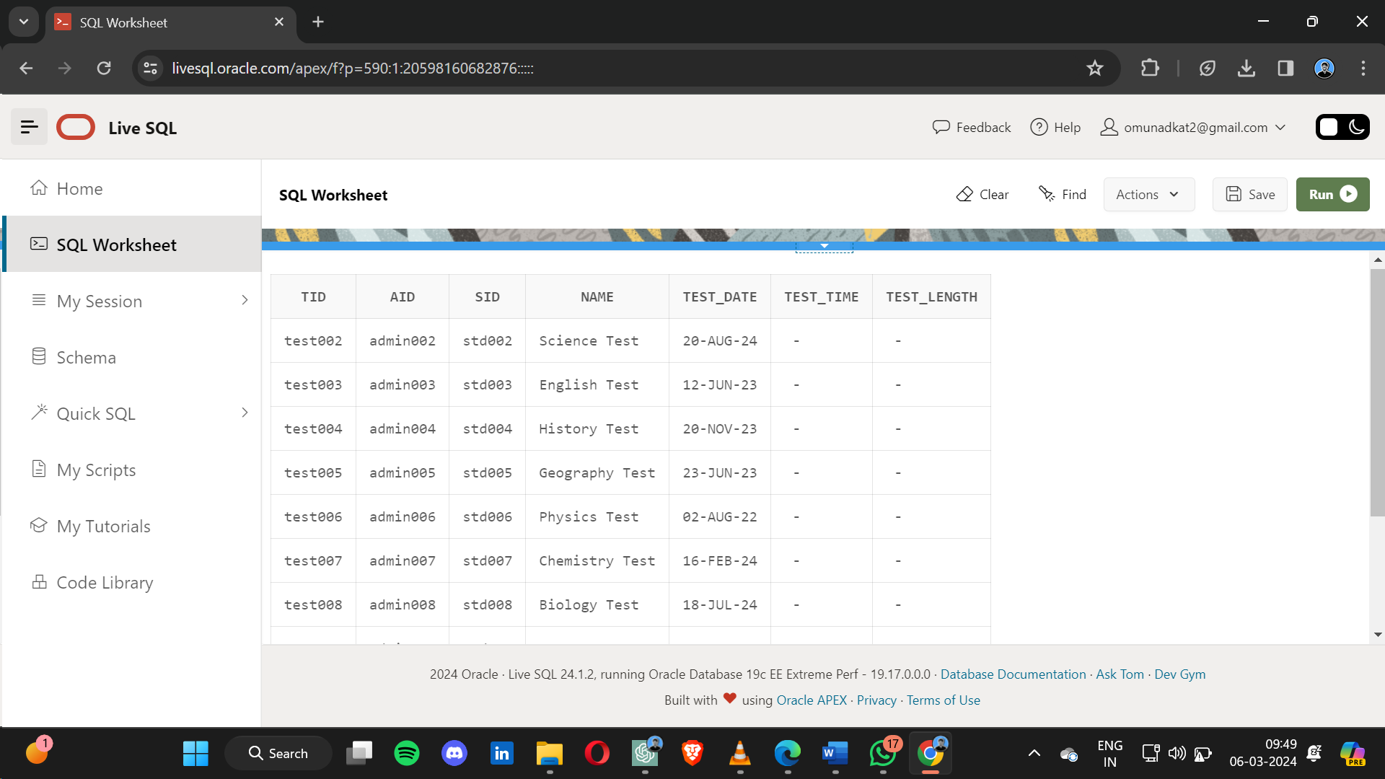

* 1. Results

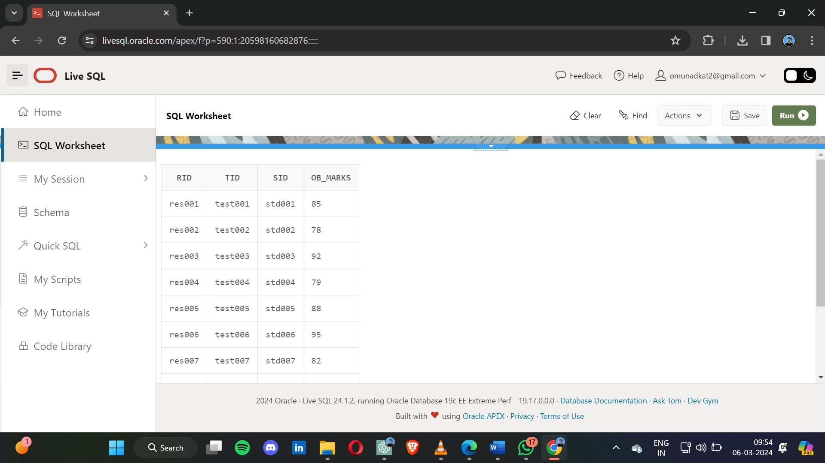

* 1. Course

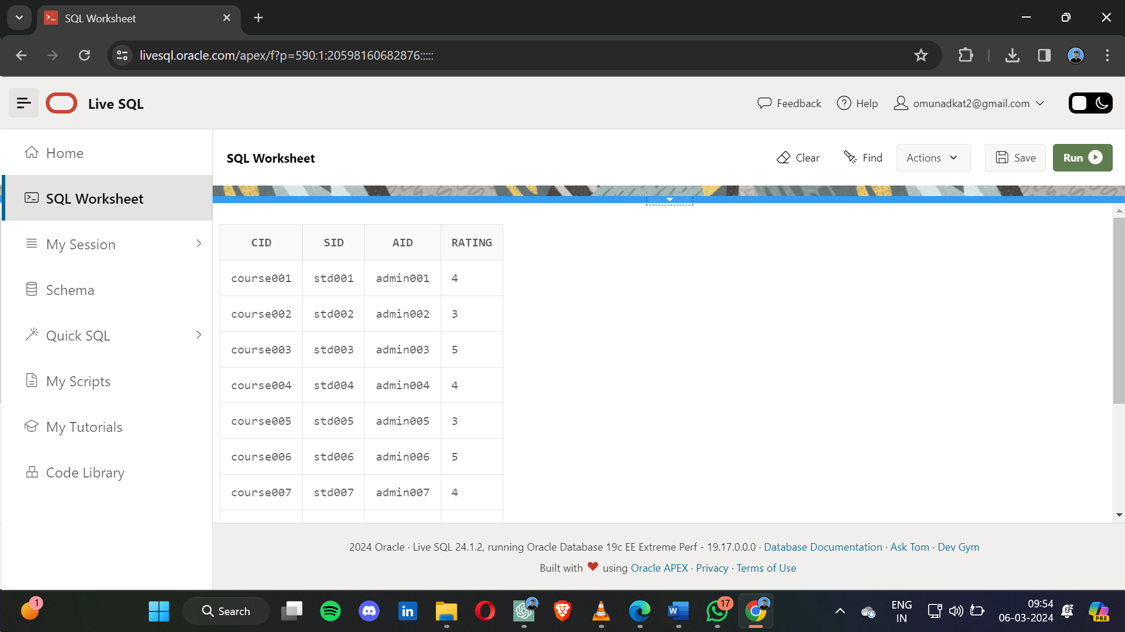

* 1. Paid_course

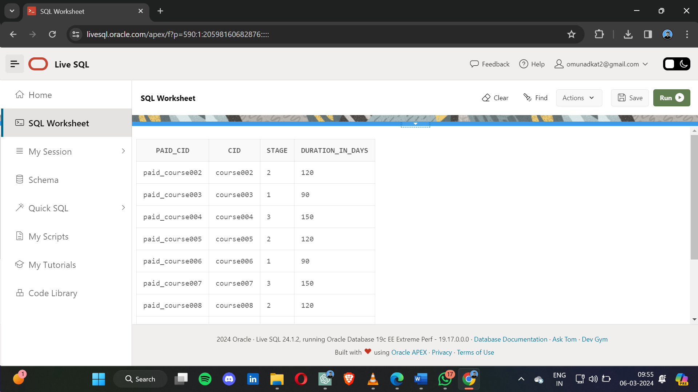

* 1. Free_course

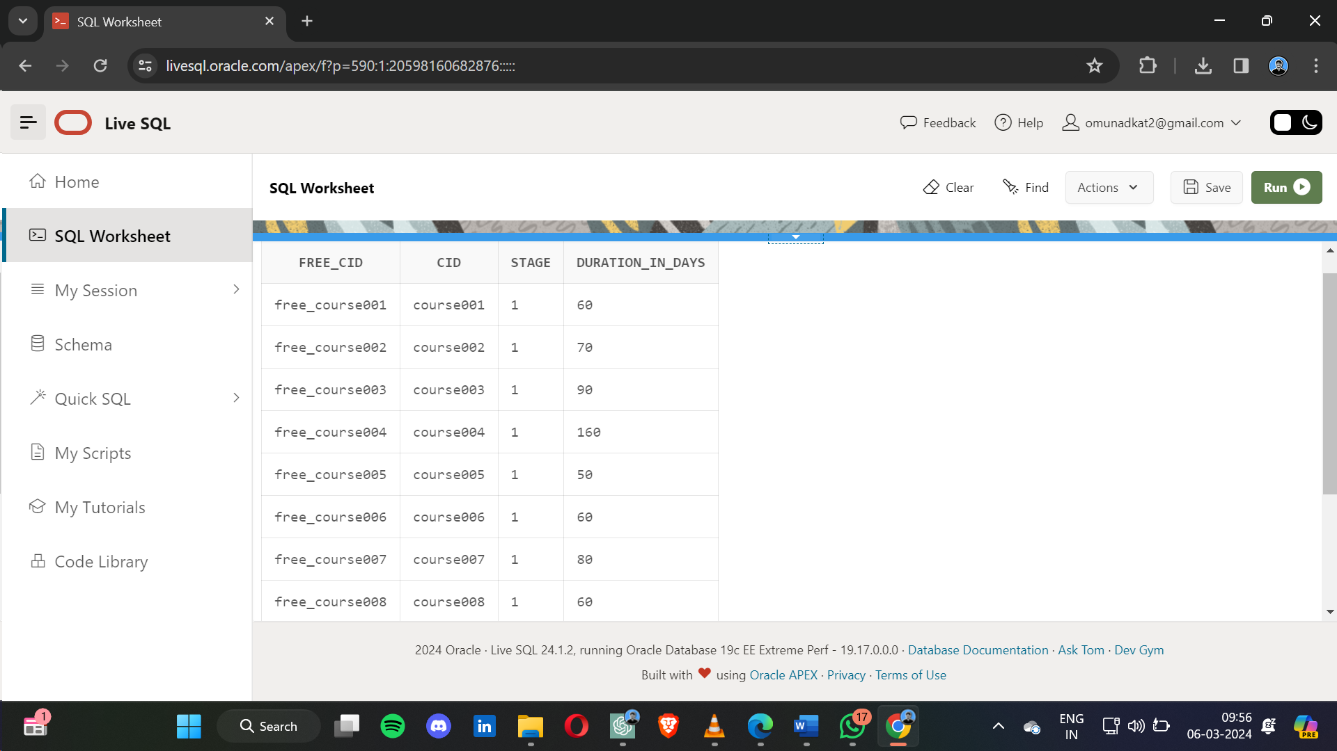

* 1. feedback

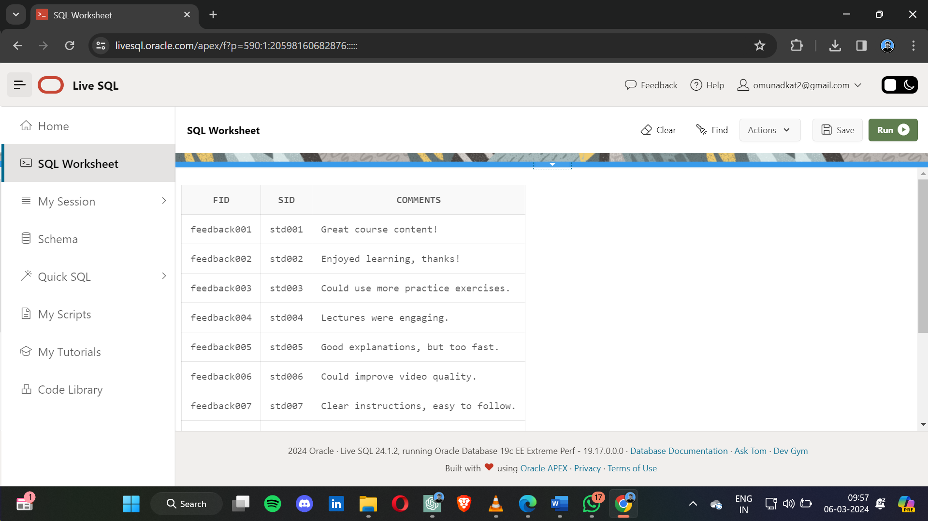

* 1. Certificate

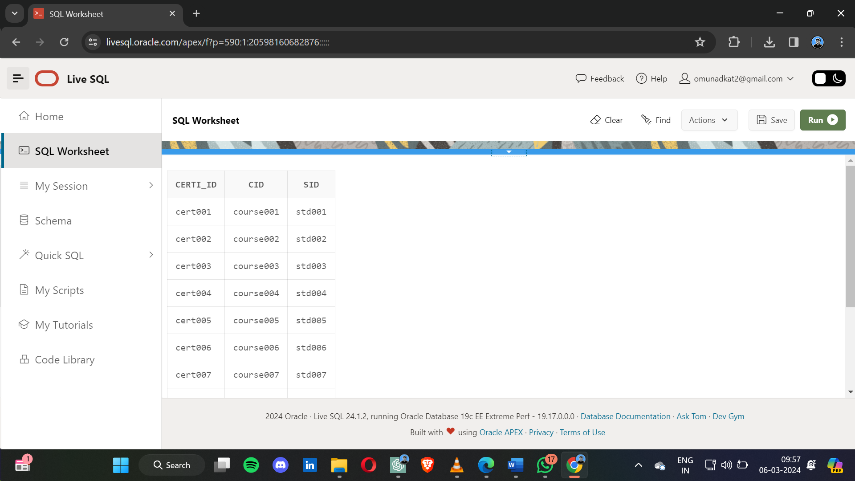

* 1. Payment

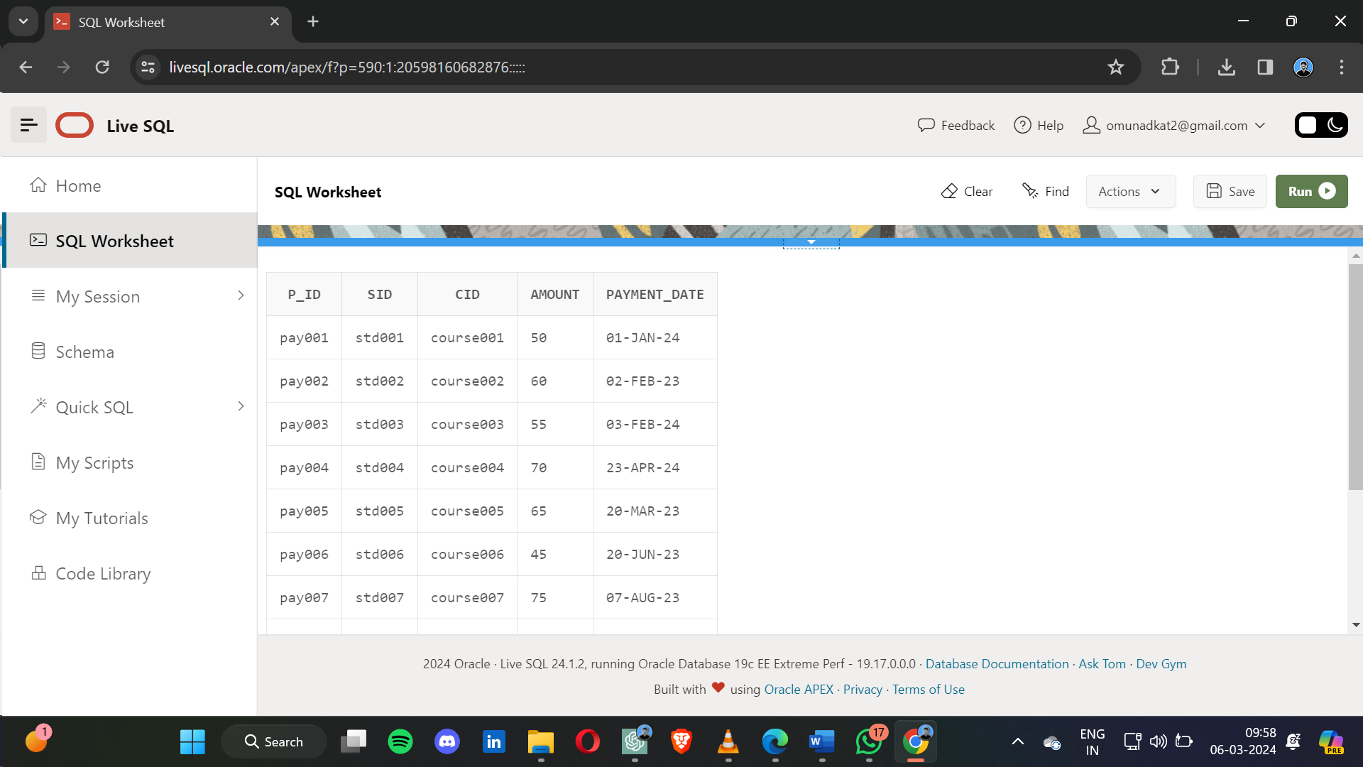

* 1. Methods

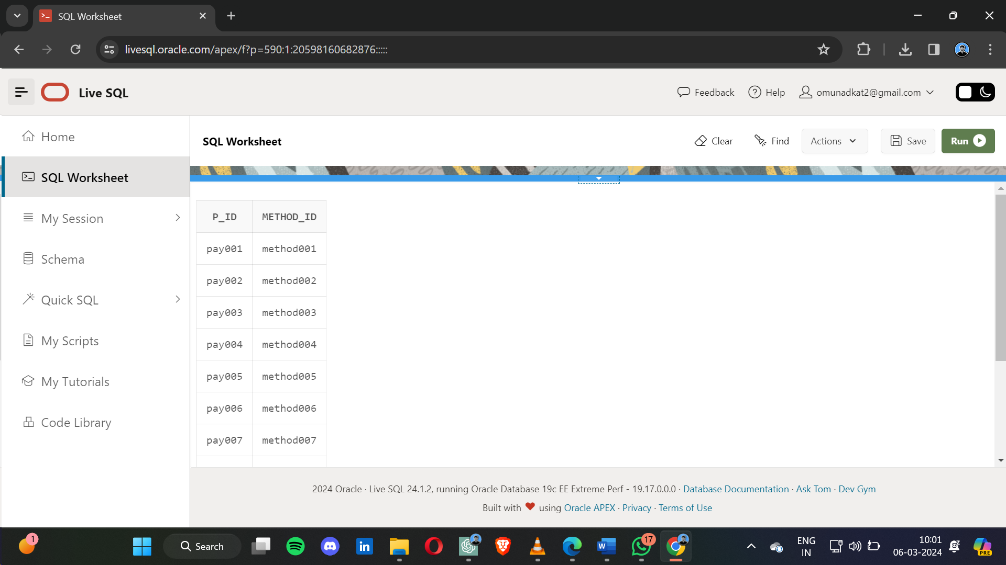

* 1. upi

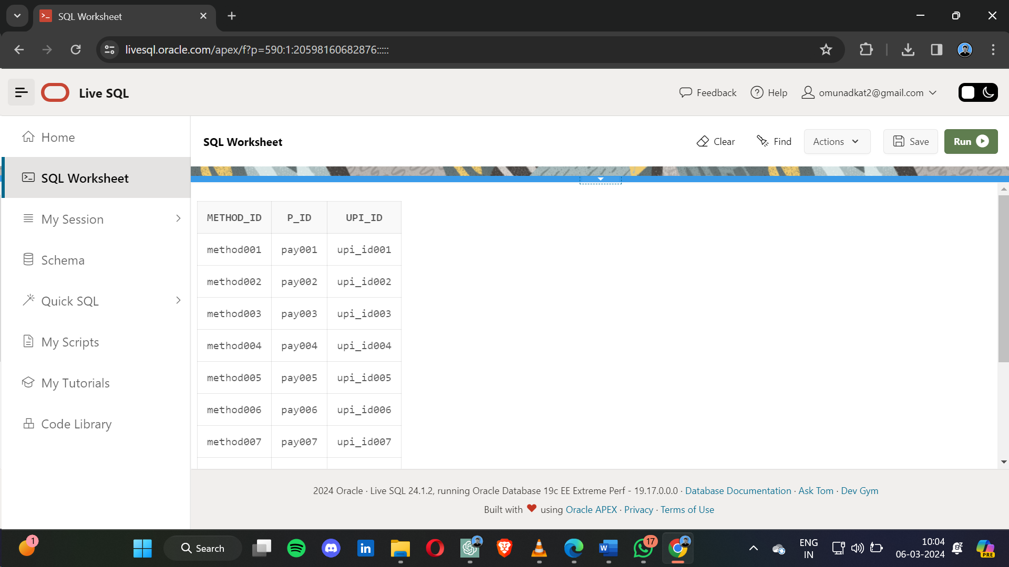

4.13 Net Banking

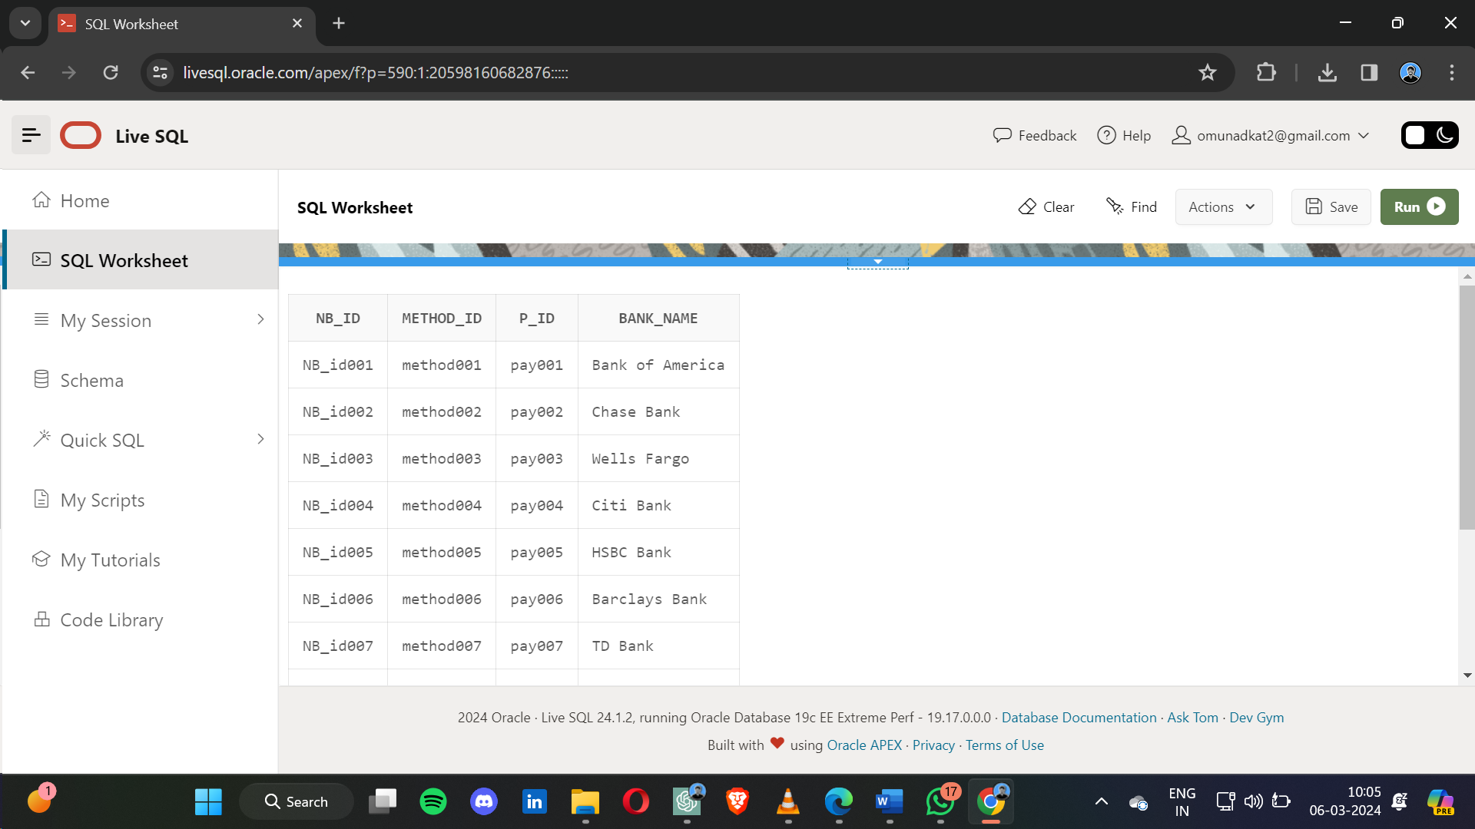

4.14 Debit and Credit Cards

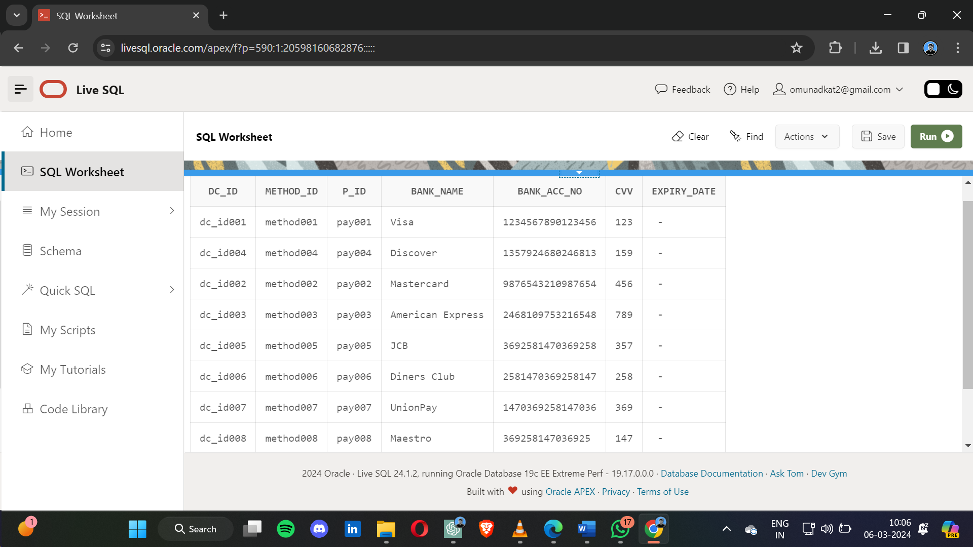

4.15 video lec

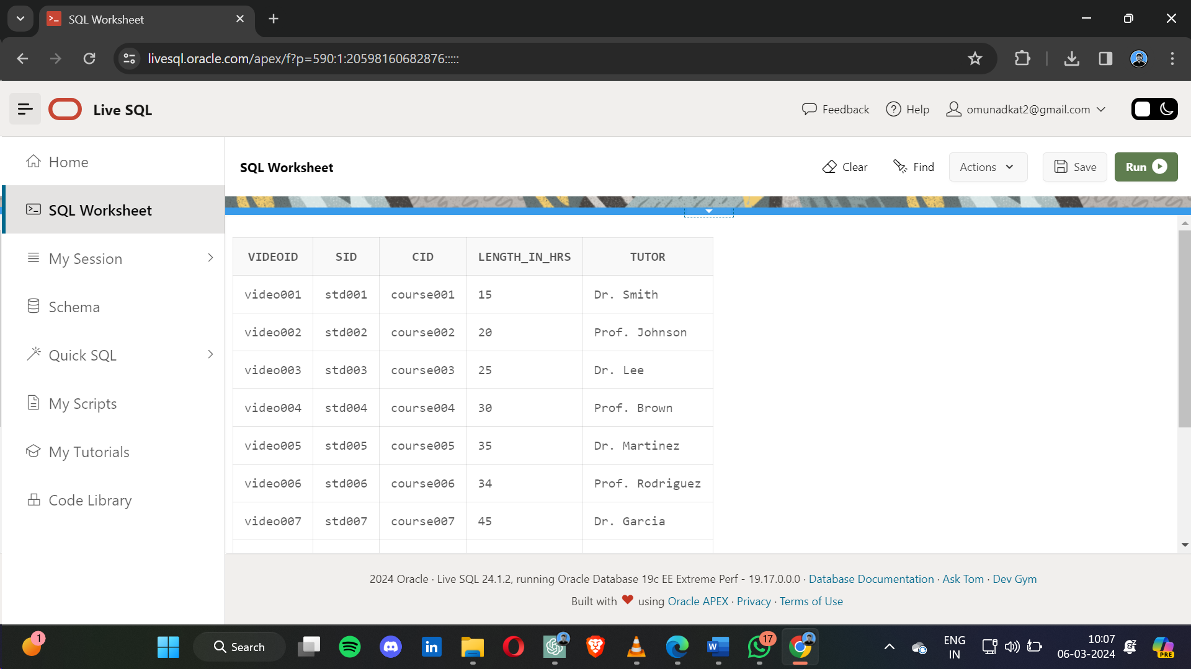

## DATA IMPLEMENTATION

1. **SCHEMA**

### Admin:

create table admin

(

aid varchar (100) not null primary key,

pswd varchar (80) not null

);

### 5.1.2 Student:

CREATE TABLE STUDENT(

sid varchar(100) not null primary key,

pwd varchar(100) not null,

s_name varchar(15),

sage varchar(2),

sdob date,

s_email varchar(25),

s_phone numeric(10)

);

### Test:

CREATE TABLE TEST

(

tid varchar(100) NOT NULL PRIMARY KEY,

aid,

sid,

name varchar2(20) NOT NULL,

test_date date,

test_time timestamp,

test_length timestamp,

CONSTRAINT t_aid FOREIGN KEY (aid) REFERENCES admin(aid),

CONSTRAINT t_sid FOREIGN KEY (sid) REFERENCES student(sid)

)

### Results:

CREATE TABLE results (

rid VARCHAR2(100) primary key ,

tid,

sid,

ob_marks numeric(3),

CONSTRAINT r_tid FOREIGN KEY (tid) REFERENCES test(tid),

CONSTRAINT r_sid FOREIGN KEY (sid) REFERENCES student(sid)

)

### Course:

CREATE TABLE COURSE

(

cid varchar2(100) NOT NULL PRIMARY KEY,

sid,

aid,

rating numeric(2),

CONSTRAINT c_tid FOREIGN KEY (aid) REFERENCES admin(aid),

CONSTRAINT c_sid FOREIGN KEY (sid) REFERENCES student(sid)

)

### FREE COURSE

CREATE TABLE FREE_COURSE

(

free_cid varchar(100) NOT NULL PRIMARY KEY,

cid,

stage integer,

duration_In_Days numeric,

CONSTRAINT f_cid FOREIGN KEY (cid) REFERENCES course(cid)

)

### PAID COURSE

CREATE TABLE PAID_COURSE

(

paid_cid varchar2(100) NOT NULL PRIMARY KEY,

cid ,

stage numeric(3),

duration_In_Days numeric(3),

CONSTRAINT p_cid FOREIGN KEY (cid) REFERENCES course(cid)

)

### CERTIFICATE

create table certificate(

certi_id varchar(100) not null primary key,

cid ,

sid ,

CONSTRAINT certi_cid FOREIGN KEY (cid) REFERENCES course(cid),

CONSTRAINT certi_sid FOREIGN KEY (sid) REFERENCES student(sid)

)

### FEEDBACK :

create table feedback(

fid varchar2(100) PRIMARY KEY NOT NULL,

sid ,

comments varchar2(200),

CONSTRAINT feed_sid FOREIGN KEY (sid) REFERENCES student(sid)

)

### VIDEO LEC :

create table videolec(

videoid varchar2(10) not null primary key,

sid,

cid,

length_In_Hrs numeric(2),

tutor varchar(20),

CONSTRAINT vid_course FOREIGN KEY (cid) REFERENCES course(cid),

CONSTRAINT vid_student FOREIGN KEY (sid) REFERENCES student(sid)

)

### PAYMENT

create table payment(

p_id varchar2(160) not null primary key,

sid ,

cid ,

amount numeric(10),

payment_date date,

constraints pay_cid foreign key(cid) references course(cid),

constraints pay_sid foreign key(sid) references student(sid)

)

**5.1.12 METHODS**

CREATE TABLE METHODS(

p_id ,

method_id varchar2(100) not null primary key,

constraints pid_method foreign key(p_id) references payment(p_id)

)

**5.1.13 UPI :**

CREATE TABLE UPI(

method_id ,

p_id ,

upi_id VARCHAR2(20) primary key ,

constraints upi_pid foreign key(p_id) references payment(p_id),

constraints upi_mid foreign key(method_id) references methods(method_id)

)

### Net_Banking

CREATE TABLE NET_BANKING1 (

NB_id varchar2(200) primary key,

method_id,

p_id ,

bank_name varchar2(25) not null,

CONSTRAINT nb_pid1 FOREIGN KEY(p_id) REFERENCES payment(p_id),

CONSTRAINT nb_method_id1 FOREIGN KEY(method_id) REFERENCES methods(method_id)

)

### DEBIT_CREDIT_CARDS

CREATE TABLE DEBIT_CREDIT_CARDS

(

dc_id varchar2(20) primary key,

method_id ,

p_id ,

bank_name varchar2(25) not null,

bank_acc_no numeric(20) unique not null,

cvv numeric(3) not null,

expiry_date date,

constraints dc_pid foreign key(p_id) references payment(p_id),

constraints dc_mid foreign key(method_id) references methods(method_id)

)

## DATA INSERTION

**5.2.1 Admin**

INSERT INTO admin (aid, pswd) VALUES ('admin001', 'pass123');

INSERT INTO admin (aid, pswd) VALUES ('admin002', 'admin456');

INSERT INTO admin (aid, pswd) VALUES ('admin003', 'secure789');

INSERT INTO admin (aid, pswd) VALUES ('admin004', 'secret321');

INSERT INTO admin (aid, pswd) VALUES ('admin005', 'adminpass');

INSERT INTO admin (aid, pswd) VALUES ('admin006', 'passadmin');

INSERT INTO admin (aid, pswd) VALUES ('admin007', 'password1');

INSERT INTO admin (aid, pswd) VALUES ('admin008', 'passadmin123');

INSERT INTO admin (aid, pswd) VALUES ('admin009', 'securepass');

INSERT INTO admin (aid, pswd) VALUES ('admin010', 'passadmin456');

### 5.2.2: STUDENT:

INSERT INTO Student (sid, pwd, s_name, sage, sdob, s_email, s_phone) VALUES ('std001', 'stdpass1', 'John Doe', '20', '10-JAN-2004', 'john@example.com', '1234567890');

INSERT INTO Student (sid, pwd, s_name, sage, sdob, s_email, s_phone) VALUES ('std002', 'stdpass2', 'Jane Smith', '22', '13-FEB-2003', 'jane@example.com', '9876543210');

INSERT INTO Student (sid, pwd, s_name, sage, sdob, s_email, s_phone) VALUES ('std003', 'stdpass3', 'Michael Johnson', '19', '09-MAR-2005', 'michael@example.com', '4567890123');

INSERT INTO Student (sid, pwd, s_name, sage, sdob, s_email, s_phone) VALUES ('std004', 'stdpass4', 'Emily Brown', '21', '25-JULY-2005', 'emily@example.com', '7890123456');

INSERT INTO Student (sid, pwd, s_name, sage, sdob, s_email,s_phone) VALUES ('std005', 'stdpass5', 'David Wilson', '23', '30-MAR-2001', 'david@example.com', '2109876543');

INSERT INTO Student (sid, pwd, s_name, sage, sdob, s_email, s_phone) VALUES ('std006', 'stdpass6', 'Sarah Lee', '20', '05-AUG-2004', 'sarah@example.com', '3210987654');

INSERT INTO Student (sid, pwd, s_name, sage, sdob, s_email, s_phone) VALUES ('std007', 'stdpass7', 'Christo Garcia', '22', '11-DEC-2002', 'chris@example.com', '6543210987');

INSERT INTO Student (sid, pwd, s_name, sage, sdob, s_email, s_phone) VALUES ('std008', 'stdpass8', 'Amanda Martinez', '19', '18-FEB-2005', 'amanda@example.com', '2345678901');

INSERT INTO Student (sid, pwd, s_name, sage, sdob, s_email, s_phone) VALUES ('std009', 'stdpass9', 'James Rodriguez', '21', '23-APR-2004', 'james@example.com', '8901234567');

INSERT INTO Student (sid, pwd, s_name, sage, sdob, s_email, s_phone) VALUES ('std010', 'stdpass10', 'Ashley Herna', '23', '20-JUN-2002', 'ashley@example.com', '4321098765');

**5.2.3 TEST** :  
INSERT INTO Test (tid, aid, sid, name,test_date) VALUES ('test001', 'admin001', 'std001', 'Math Test','21-APR-2023');

INSERT INTO Test (tid, aid, sid, name,test_date) VALUES ('test002', 'admin002', 'std002', 'Science Test', '20-AUG-2024' );

INSERT INTO Test (tid, aid, sid, name,test_date) VALUES ('test003', 'admin003', 'std003', 'English Test', '12-JUN-2023' );

INSERT INTO Test (tid, aid, sid, name,test_date) VALUES ('test004', 'admin004', 'std004', 'History Test', '20-NOV-2023' );

INSERT INTO Test (tid, aid, sid, name,test_date) VALUES ('test005', 'admin005', 'std005', 'Geography Test', '23-JUN-2023');

INSERT INTO Test (tid, aid, sid, name,test_date) VALUES ('test006', 'admin006', 'std006', 'Physics Test', '2-AUG-2022' );

INSERT INTO Test (tid, aid, sid, name,test_date) VALUES ('test007', 'admin007', 'std007', 'Chemistry Test', '16-FEB-2024');

INSERT INTO Test (tid, aid, sid, name,test_date) VALUES ('test008', 'admin008', 'std008', 'Biology Test', '18-JULY-2024' );

INSERT INTO Test (tid, aid, sid, name,test_date) VALUES ('test009', 'admin009', 'std009', 'Computer Science Test', '18-MAR-2024' );

INSERT INTO Test (tid, aid, sid, name,test_date) VALUES ('test010', 'admin010', 'std010', 'Art Test', '19-FEB-2024' );

### 5.2.4 RESULTS :

INSERT INTO results (rid, tid, sid, ob_marks) VALUES ('res001', 'test001', 'std001', 85);

INSERT INTO results (rid, tid, sid, ob_marks) VALUES ('res002', 'test002', 'std002', 78);

INSERT INTO results (rid, tid, sid, ob_marks) VALUES ('res003', 'test003', 'std003', 92);

INSERT INTO results (rid, tid, sid, ob_marks) VALUES ('res004', 'test004', 'std004', 79);

INSERT INTO results (rid, tid, sid, ob_marks) VALUES ('res005', 'test005', 'std005', 88);

INSERT INTO results (rid, tid, sid, ob_marks) VALUES ('res006', 'test006', 'std006', 95);

INSERT INTO results (rid, tid, sid, ob_marks) VALUES ('res007', 'test007', 'std007', 82);

INSERT INTO results (rid, tid, sid, ob_marks) VALUES ('res008', 'test008', 'std008', 90);

INSERT INTO results (rid, tid, sid, ob_marks) VALUES ('res009', 'test009', 'std009', 87);

INSERT INTO results (rid, tid, sid, ob_marks) VALUES ('res010', 'test010', 'std010', 91) ;

**5.2.5 COURSE** :

INSERT INTO course (cid, sid, aid, rating) VALUES ('course001', 'std001', 'admin001', 4);

INSERT INTO course (cid, sid, aid, rating) VALUES ('course002', 'std002', 'admin002', 3);

INSERT INTO course (cid, sid, aid, rating) VALUES ('course003', 'std003', 'admin003', 5);

INSERT INTO course (cid, sid, aid, rating) VALUES ('course004', 'std004', 'admin004', 4);5

INSERT INTO course (cid, sid, aid, rating) VALUES ('course005', 'std005', 'admin005', 3);

INSERT INTO course (cid, sid, aid, rating) VALUES ('course006', 'std006', 'admin006', 5);

INSERT INTO course (cid, sid, aid, rating) VALUES ('course007', 'std007', 'admin007', 4);

INSERT INTO course (cid, sid, aid, rating) VALUES('course008', 'std008', 'admin008', 3);

INSERT INTO course (cid, sid, aid, rating) VALUES('course009', 'std009', 'admin009', 5);

INSERT INTO course (cid, sid, aid, rating) VALUES ('course010', 'std010', 'admin010', 4);

**5.2.6 FREE_COURSE :**INSERT INTO free_course (free_cid, cid, stage, duration_In_Days) ('free_course001', 'course001', 1, 60);

INSERT INTO free_course (free_cid, cid, stage, duration_In_Days) VALUES ('free_course002', 'course002', 1, 70 );

INSERT INTO free_course (free_cid, cid, stage, duration_In_Days)VALUES('free_course003', 'course003', 1, 90 );

INSERT INTO free_course (free_cid, cid, stage, duration_In_Days) VALUES ('free_course004', 'course004', 1, 160 );

INSERT INTO free_course (free_cid, cid, stage, duration_In_Days)VALUES ('free_course005', 'course005', 1, 50 );

INSERT INTO free_course (free_cid, cid, stage, duration_In_Days) VALUES ('free_course006', 'course006', 1, 60 );

INSERT INTO free_course (free_cid, cid, stage, duration_In_Days)VALUES ('free_course007', 'course007', 1, 80 );

INSERT INTO free_course (free_cid, cid, stage, duration_In_Days) VALUES('free_course008', 'course008', 1, 60);

INSERT INTO free_course (free_cid, cid, stage, duration_In_Days) VALUES ('free_course009', 'course009', 1, 60 );

INSERT INTO free_course (free_cid, cid, stage, duration_In_Days) VALUES('free_course010', 'course010', 1, 80);

**5.2.7 PAID_COURSE :**INSERT INTO paid_course (paid_cid, cid, stage, duration_In_Days) VALUES ('paid_course001', 'course001', 1, 90 );

INSERT INTO paid_course (paid_cid, cid, stage, duration_In_Days) VALUES ('paid_course002', 'course002', 2, 120);

INSERT INTO paid_course (paid_cid, cid, stage, duration_In_Days) VALUES ('paid_course003', 'course003', 1, 90 );

INSERT INTO paid_course (paid_cid, cid, stage, duration_In_Days) VALUES ('paid_course004', 'course004', 3, 150);

INSERT INTO paid_course (paid_cid, cid, stage, duration_In_Days) VALUES ('paid_course005', 'course005', 2, 120);

INSERT INTO paid_course (paid_cid, cid, stage, duration_In_Days) VALUES ('paid_course006', 'course006', 1, 90 );

INSERT INTO paid_course (paid_cid, cid, stage, duration_In_Days) VALUES ('paid_course007', 'course007', 3, 150);

INSERT INTO paid_course (paid_cid, cid, stage, duration_In_Days) VALUES ('paid_course008', 'course008', 2, 120 );

INSERT INTO paid_course (paid_cid, cid, stage, duration_In_Days) VALUES ('paid_course009', 'course009', 1, 90 );

INSERT INTO paid_course (paid_cid, cid, stage, duration_In_Days) VALUES ('paid_course010', 'course010', 3, 150 );

**5.2.8 FEEDBACK :**INSERT INTO feedback (fid, sid, comments) VALUES ('feedback001', 'std001', 'Great course content!');

INSERT INTO feedback (fid, sid, comments) VALUES ('feedback002', 'std002', 'Enjoyed learning, thanks!');

INSERT INTO feedback (fid, sid, comments) VALUES ('feedback003', 'std003', 'Could use more practice exercises.');

INSERT INTO feedback (fid, sid, comments) VALUES ('feedback004', 'std004', 'Lectures were engaging.');

INSERT INTO feedback (fid, sid, comments) VALUES ('feedback005', 'std005', 'Good explanations, but too fast.');

INSERT INTO feedback (fid, sid, comments) VALUES ('feedback006', 'std006', 'Could improve video quality.');

INSERT INTO feedback (fid, sid, comments) VALUES ('feedback007', 'std007', 'Clear instructions, easy to follow.');

INSERT INTO feedback (fid, sid, comments) VALUES ('feedback008', 'std008', 'Interesting topics covered.');

INSERT INTO feedback (fid, sid, comments) VALUES ('feedback009', 'std009', 'Needs more real-world examples.');

INSERT INTO feedback (fid, sid, comments) VALUES ('feedback010', 'std010', 'Excellent support from tutors!');  
  
  
  
**5.2.9 CERTIFICATE :**INSERT INTO certificate (certi_id, cid, sid) VALUES ('cert001', 'course001', 'std001');

INSERT INTO certificate (certi_id, cid, sid) VALUES ('cert002', 'course002', 'std002');

INSERT INTO certificate (certi_id, cid, sid) VALUES ('cert003', 'course003', 'std003');

INSERT INTO certificate (certi_id, cid, sid) VALUES ('cert004', 'course004', 'std004');

INSERT INTO certificate (certi_id, cid, sid) VALUES ('cert005', 'course005', 'std005');

INSERT INTO certificate (certi_id, cid, sid) VALUES ('cert006', 'course006', 'std006');

INSERT INTO certificate (certi_id, cid, sid) VALUES ('cert007', 'course007', 'std007');

INSERT INTO certificate (certi_id, cid, sid) VALUES ('cert008', 'course008', 'std008');

INSERT INTO certificate (certi_id, cid, sid) VALUES('cert009', 'course009', 'std009');

INSERT INTO certificate (certi_id, cid, sid) VALUES ('cert010', 'course010', 'std010');

**5 .2.10 Videolec :**INSERT INTO videolec (videoid, sid, cid, length_In_Hrs, tutor) VALUES ('video001', 'std001', 'course001', 15, 'Dr. Smith');

INSERT INTO videolec (videoid, sid, cid, length_In_Hrs, tutor) VALUES ('video002', 'std002', 'course002', 20, 'Prof. Johnson');

INSERT INTO videolec (videoid, sid, cid, length_In_Hrs, tutor) VALUES ('video003', 'std003', 'course003', 25, 'Dr. Lee');

INSERT INTO videolec (videoid, sid, cid, length_In_Hrs, tutor) VALUES('video004', 'std004', 'course004', 30, 'Prof. Brown');

INSERT INTO videolec (videoid, sid, cid, length_In_Hrs, tutor) VALUES ('video005', 'std005', 'course005', 35, 'Dr. Martinez');

INSERT INTO videolec (videoid, sid, cid, length_In_Hrs, tutor) VALUES ('video006', 'std006', 'course006', 34, 'Prof. Rodriguez');

INSERT INTO videolec (videoid, sid, cid, length_In_Hrs, tutor) VALUES ('video007', 'std007', 'course007', 45, 'Dr. Garcia');

INSERT INTO videolec (videoid, sid, cid, length_In_Hrs, tutor) VALUES ('video008', 'std008', 'course008', 59, 'Prof. Hernandez');

INSERT INTO videolec (videoid, sid, cid, length_In_Hrs, tutor) VALUES('video009', 'std009', 'course009', 44, 'Dr. Wilson');

INSERT INTO videolec (videoid, sid, cid, length_In_Hrs, tutor) VALUES ('video010', 'std010', 'course010', 60, 'Prof. Smith');

**5.2.11 PAYMENT :** INSERT INTO payment (p_id, sid, cid, amount, payment_date) VALUES ('pay001', 'std001', 'course001', 50.00, '01-JAN-2024');

INSERT INTO payment (p_id, sid, cid, amount, payment_date) VALUES ('pay002', 'std002', 'course002', 60.00, '02-FEB-2023');

INSERT INTO payment (p_id, sid, cid, amount, payment_date) VALUES ('pay003', 'std003', 'course003', 55.00, '03-FEB-2024');

INSERT INTO payment (p_id, sid, cid, amount, payment_date) VALUES ('pay004', 'std004', 'course004', 70.00, '23-APR-2024');

INSERT INTO payment (p_id, sid, cid, amount, payment_date) VALUES ('pay005', 'std005', 'course005', 65.00, '20-MAR-2023');

INSERT INTO payment (p_id, sid, cid, amount, payment_date) VALUES ('pay006', 'std006', 'course006', 45.00, '20-JUN-2023');

INSERT INTO payment (p_id, sid, cid, amount, payment_date) VALUES ('pay007', 'std007', 'course007', 75.00, '07-AUG-2023');

INSERT INTO payment (p_id, sid, cid, amount, payment_date) VALUES ('pay008', 'std008', 'course008', 40.00, '18-JUL-2023');

INSERT INTO payment (p_id, sid, cid, amount, payment_date) VALUES ('pay009', 'std009', 'course009', 85.00, '19-NOV-2023');

INSERT INTO payment (p_id, sid, cid, amount, payment_date) VALUES ('pay010', 'std010', 'course010', 55.00, '30-OCT-2024');

**5.2.12 METHODS :**INSERT INTO methods (p_id, method_id) VALUES ('pay001', 'method001');

INSERT INTO methods (p_id, method_id) VALUES ('pay002', 'method002');

INSERT INTO methods (p_id, method_id) VALUES ('pay003', 'method003');

INSERT INTO methods (p_id, method_id) VALUES ('pay004', 'method004');

INSERT INTO methods (p_id, method_id) VALUES ('pay005', 'method005');

INSERT INTO methods (p_id, method_id) VALUES ('pay006', 'method006');

INSERT INTO methods (p_id, method_id) VALUES ('pay007', 'method007');

INSERT INTO methods (p_id, method_id) VALUES ('pay008', 'method008');

INSERT INTO methods (p_id, method_id) VALUES ('pay009', 'method009');

INSERT INTO methods (p_id, method_id) VALUES('pay010', 'method010');  
  
**5.2.13 UPI :**  
INSERT INTO upi (method_id, p_id, upi_id) VALUES ('method001', 'pay001', 'upi_id001');

INSERT INTO upi (method_id, p_id, upi_id) VALUES ('method002', 'pay002', 'upi_id002');

INSERT INTO upi (method_id, p_id, upi_id) VALUES ('method003', 'pay003', 'upi_id003');

INSERT INTO upi (method_id, p_id, upi_id) VALUES ('method004', 'pay004', 'upi_id004');

INSERT INTO upi (method_id, p_id, upi_id) VALUES ('method005', 'pay005', 'upi_id005');

INSERT INTO upi (method_id, p_id, upi_id) VALUES ('method006', 'pay006', 'upi_id006');

INSERT INTO upi (method_id, p_id, upi_id) VALUES ('method007', 'pay007', 'upi_id007');

INSERT INTO upi (method_id, p_id, upi_id) VALUES ('method008', 'pay008', 'upi_id008');

INSERT INTO upi (method_id, p_id, upi_id) VALUES ('method009', 'pay009', 'upi_id009');

INSERT INTO upi (method_id, p_id, upi_id) VALUES ('method010', 'pay010', 'upi_id010');  
  
  
  
  
5.2.14 NET_BANKING :   
  
INSERT INTO Net_Banking1 (NB_id, method_id, p_id, bank_name) VALUES ('NB_id001', 'method001', 'pay001', 'Bank of America');

INSERT INTO Net_Banking1 (NB_id, method_id, p_id, bank_name) VALUES ('NB_id002', 'method002', 'pay002', 'Chase Bank');

INSERT INTO Net_Banking1 (NB_id, method_id, p_id, bank_name) VALUES ('NB_id003', 'method003', 'pay003', 'Wells Fargo');

INSERT INTO Net_Banking1 (NB_id, method_id, p_id, bank_name) VALUES ('NB_id004', 'method004', 'pay004', 'Citi Bank');

INSERT INTO Net_Banking1 (NB_id, method_id, p_id, bank_name) VALUES('NB_id005', 'method005', 'pay005', 'HSBC Bank');

INSERT INTO Net_Banking1 (NB_id, method_id, p_id, bank_name) VALUES ('NB_id006', 'method006', 'pay006', 'Barclays Bank');

INSERT INTO Net_Banking1 (NB_id, method_id, p_id, bank_name) VALUES ('NB_id007', 'method007', 'pay007', 'TD Bank');

INSERT INTO Net_Banking1 (NB_id, method_id, p_id, bank_name) VALUES ('NB_id008', 'method008', 'pay008', 'Capital One');

INSERT INTO Net_Banking1 (NB_id, method_id, p_id, bank_name) VALUES ('NB_id009', 'method009', 'pay009', 'US Bank');

INSERT INTO Net_Banking1 (NB_id, method_id, p_id, bank_name) VALUES ('NB_id010', 'method010', 'pay010', 'PNC Bank');  
  
 **5.2.15 CREDIT_DEBIT_CARDS :**

INSERT INTO DEBIT_CREDIT_CARDS (dc_id, method_id, p_id, bank_name, bank_acc_no, cvv ) VALUES ('dc_id001', 'method001', 'pay001', 'Visa', 1234567890123456, 123 );

INSERT INTO DEBIT_CREDIT_CARDS (dc_id, method_id, p_id, bank_name, bank_acc_no, cvv ) VALUES ('dc_id002', 'method002', 'pay002', 'Mastercard', 9876543210987654, 456 );

INSERT INTO DEBIT_CREDIT_CARDS (dc_id, method_id, p_id, bank_name, bank_acc_no, cvv ) VALUES ('dc_id003', 'method003', 'pay003', 'American Express', 2468109753216548, 789 );

INSERT INTO DEBIT_CREDIT_CARDS (dc_id, method_id, p_id, bank_name, bank_acc_no, cvv ) VALUES ('dc_id004', 'method004', 'pay004', 'Discover', 1357924680246813, 159 );

INSERT INTO DEBIT_CREDIT_CARDS (dc_id, method_id, p_id, bank_name, bank_acc_no, cvv ) VALUES ('dc_id005', 'method005', 'pay005', 'JCB', 3692581470369258, 357);

INSERT INTO DEBIT_CREDIT_CARDS (dc_id, method_id, p_id, bank_name, bank_acc_no, cvv ) VALUES ('dc_id006', 'method006', 'pay006', 'Diners Club', 2581470369258147, 258);

INSERT INTO DEBIT_CREDIT_CARDS (dc_id, method_id, p_id, bank_name, bank_acc_no, cvv ) VALUES ('dc_id007', 'method007', 'pay007', 'UnionPay', 1470369258147036, 369);

INSERT INTO DEBIT_CREDIT_CARDS (dc_id, method_id, p_id, bank_name, bank_acc_no, cvv ) VALUES ('dc_id008', 'method008', 'pay008', 'Maestro', 0369258147036925, 147 );

INSERT INTO DEBIT_CREDIT_CARDS (dc_id, method_id, p_id, bank_name, bank_acc_no, cvv ) VALUES ('dc_id009', 'method009', 'pay009', 'RuPay', 3692581470369258, 258 );

INSERT INTO DEBIT_CREDIT_CARDS (dc_id, method_id, p_id, bank_name, bank_acc_no, cvv ) VALUES ('dc_id010', 'method010', 'pay010', 'Dankort', 2581470369258147, 369 );

## QUERIES USING BASIC DBMS CONSTRUCTS JOIN & SUBQUERIES:

* + 1. **1. Query using LIKE and ORDER BY:**

SELECT * FROM student WHERE s_name LIKE 'J%';  
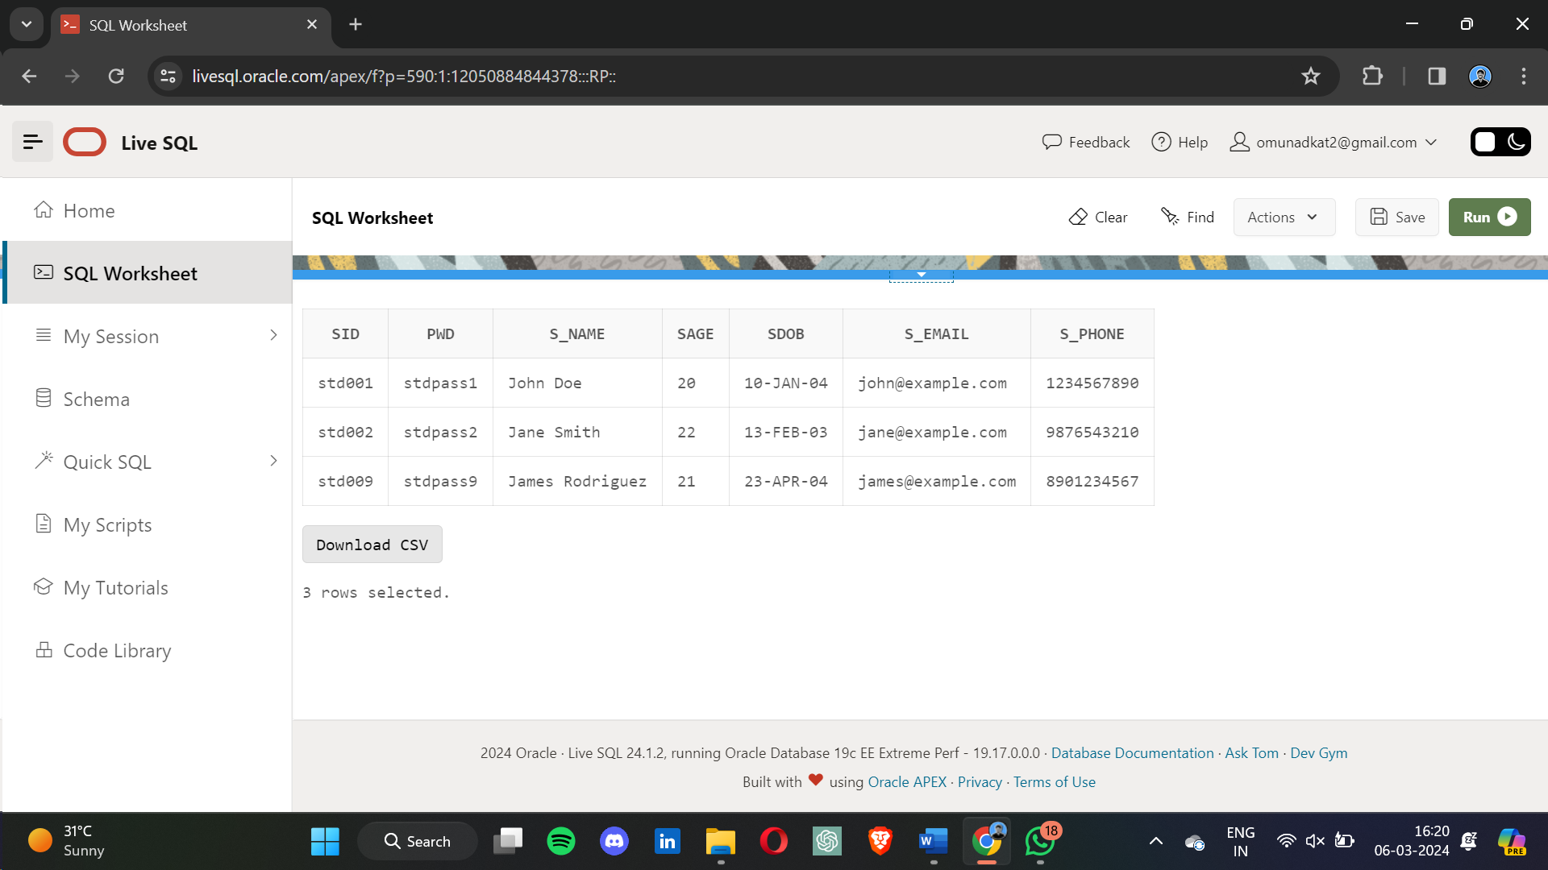

* + 1. **2. Query using BETWEEN:**

1. SELECT * FROM test WHERE test_date BETWEEN '2023-01-01' AND '2023-12-31';

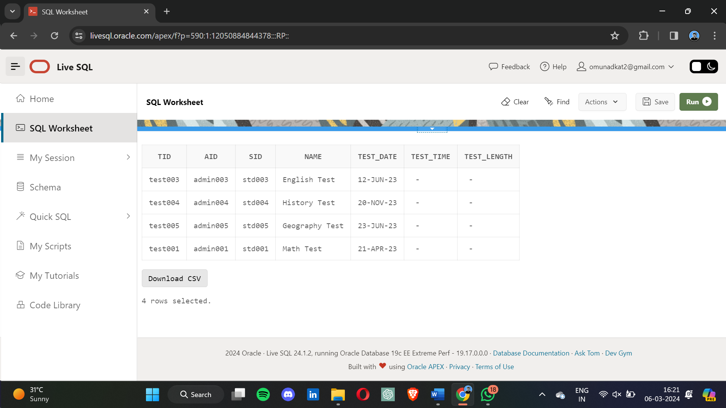

**3. Query using IN:**SELECT * FROM results WHERE ob_marks IN (85, 90, 95);  
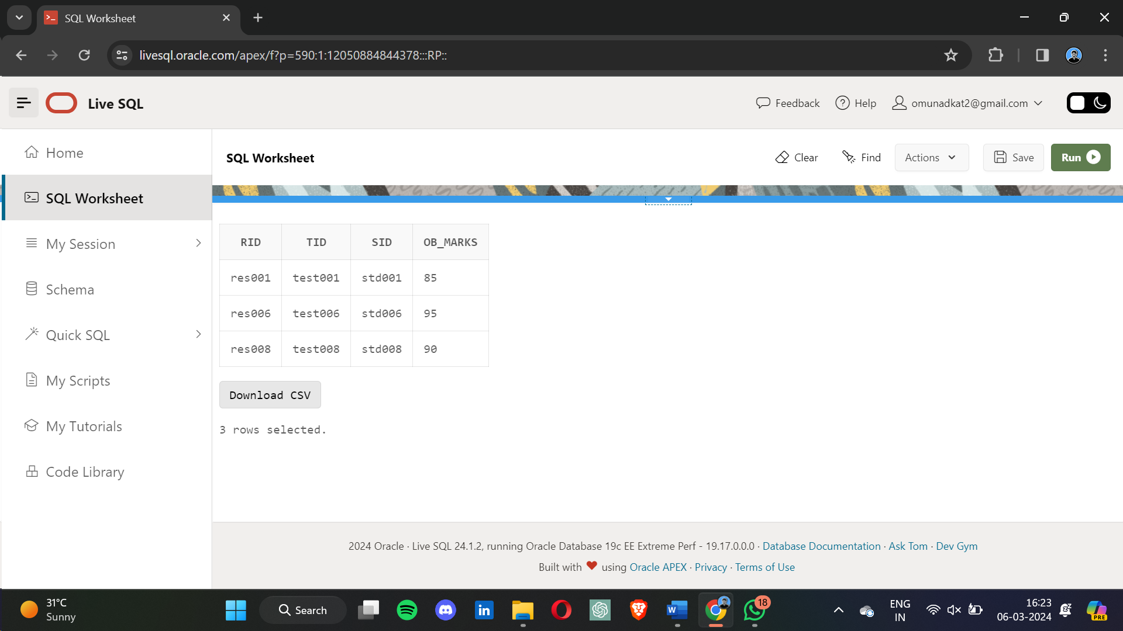

4. **Query using GROUP BY:**

SELECT sid, AVG(ob_marks) AS average_marks FROM results GROUP BY sid;  
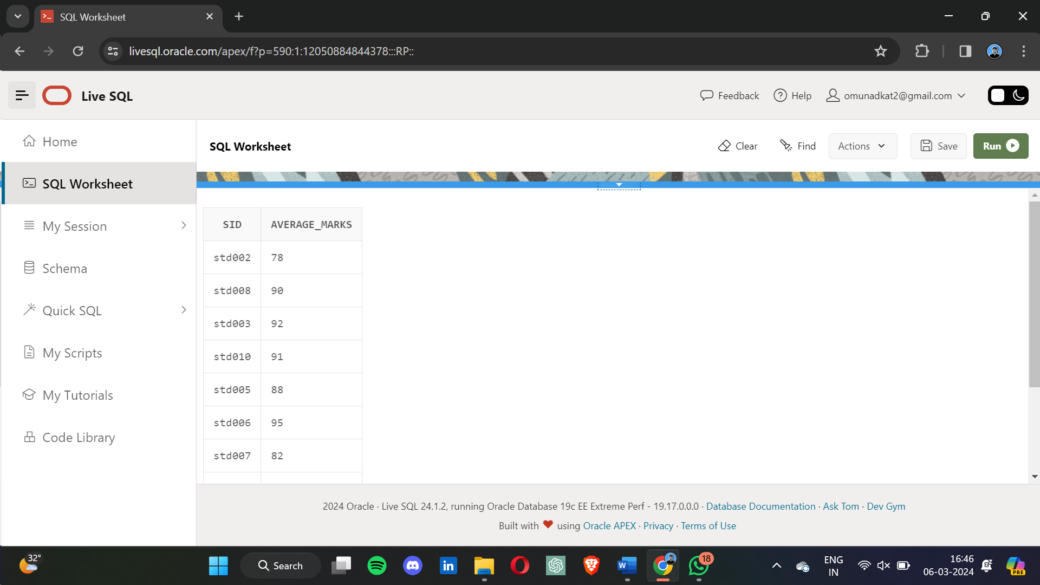

**5. Query using ORDER BY and LIMIT:**SELECT * FROM feedback ORDER BY sid ; 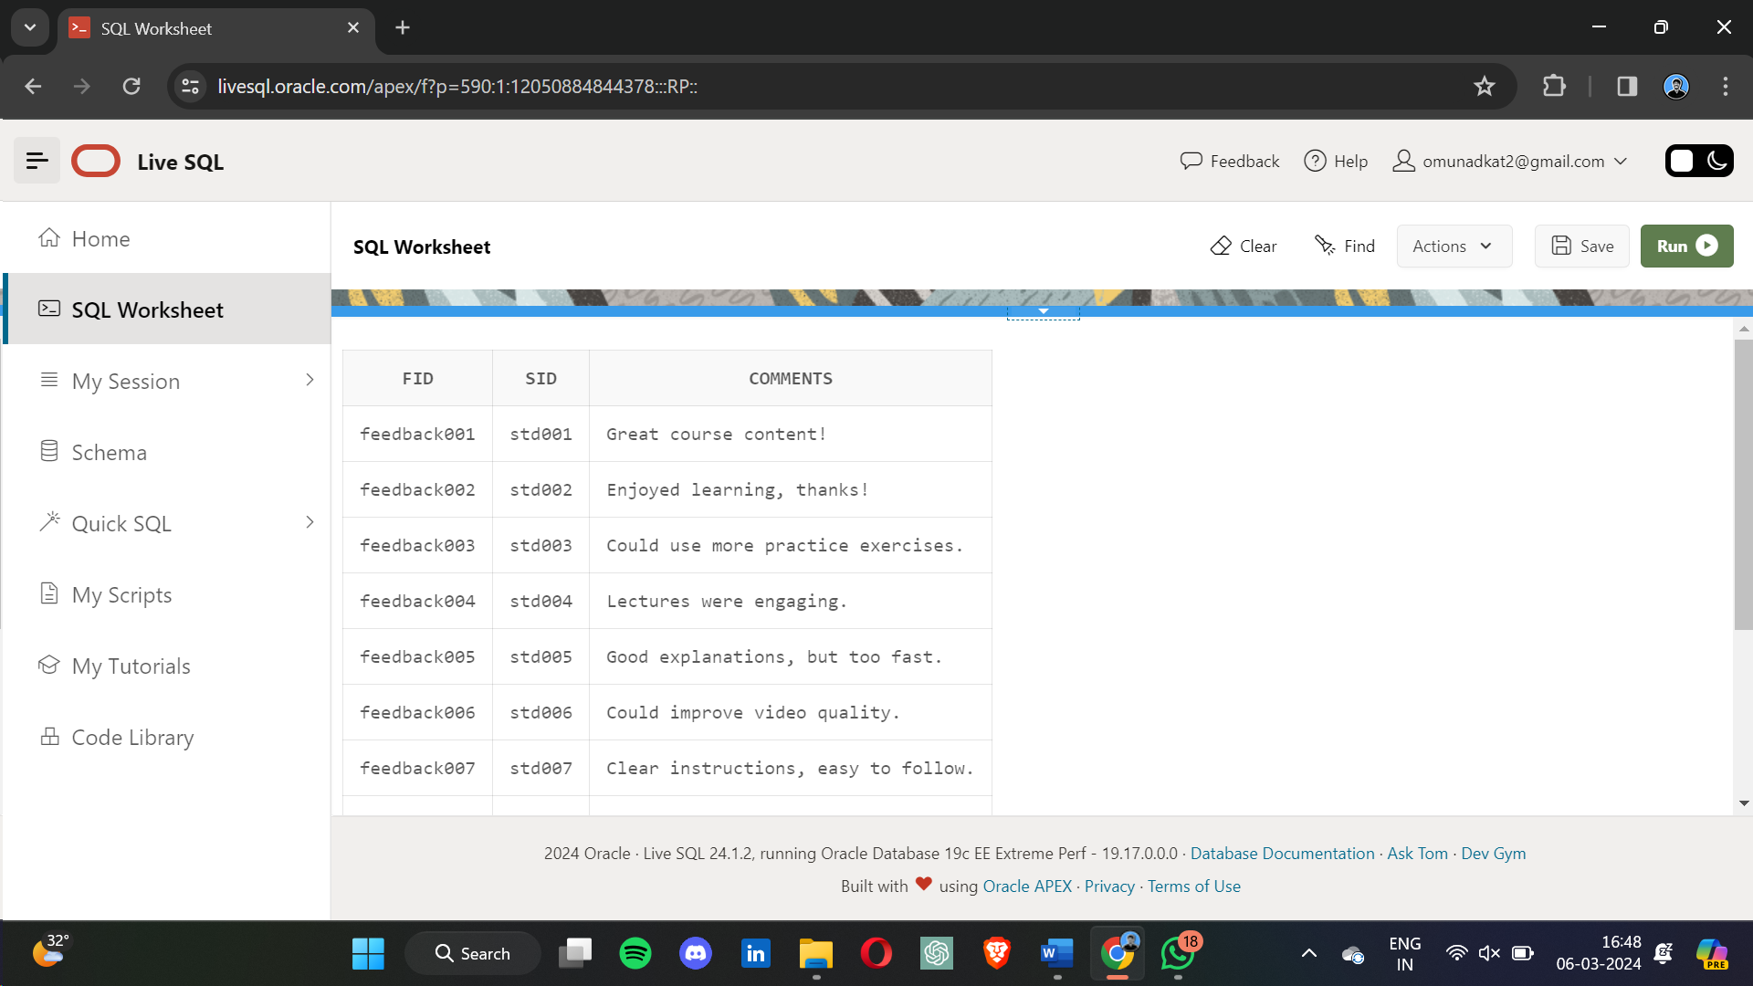

**6. Inner Join Query:**  
SELECT s.s_name, t.name FROM student s INNER JOIN test t ON s.sid = t.sid;

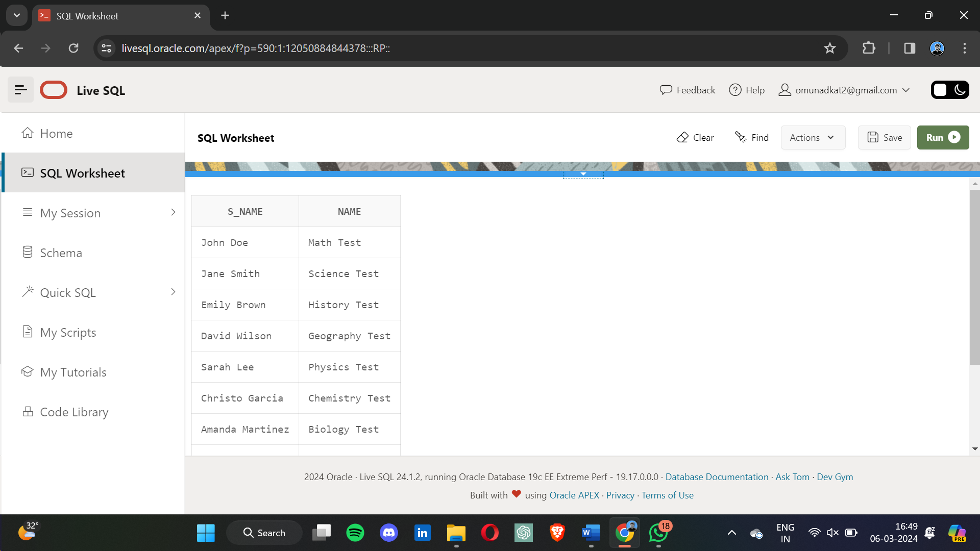 **7. Left Join Query:**  
SELECT s.s_name, r.ob_marks FROM student s LEFT JOIN results r ON s.sid = r.sid;

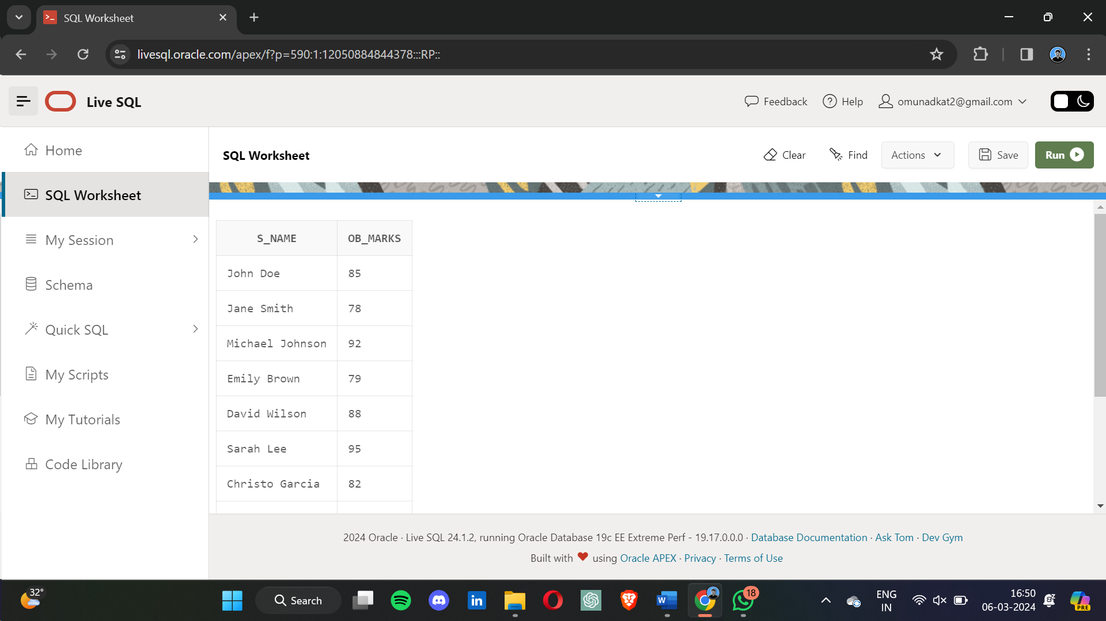 **8. Right Join Query:**  
SELECT t.name, r.ob_marks FROM test t RIGHT JOIN results r ON t.tid = r.tid;

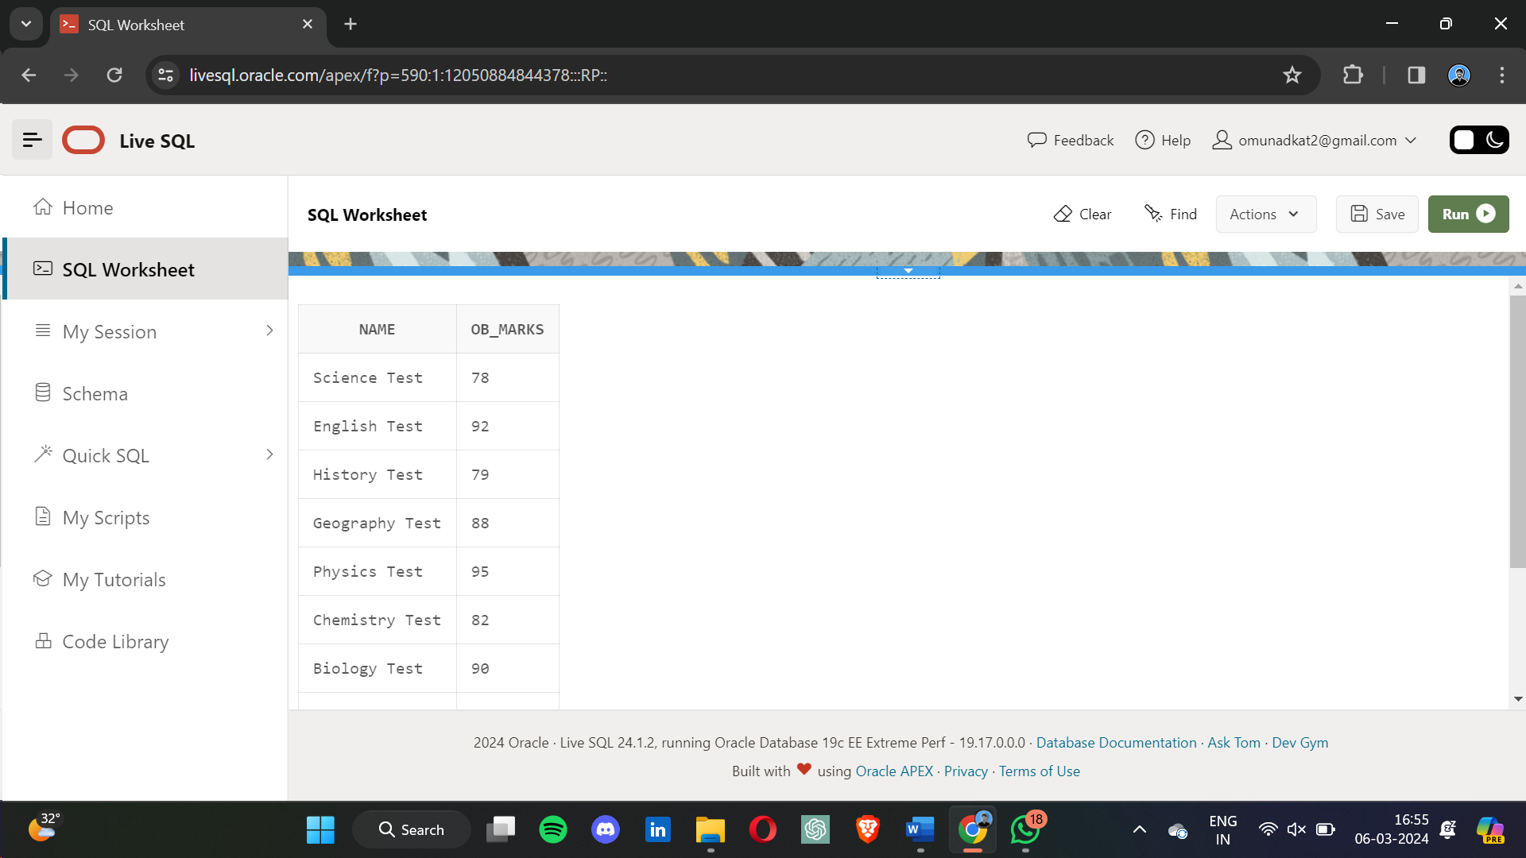 **9. OUTER JOIN QUERY :   
  
SELECT s.s_name, c.cid FROM student s FULL OUTER JOIN course c ON s.sid = c.sid;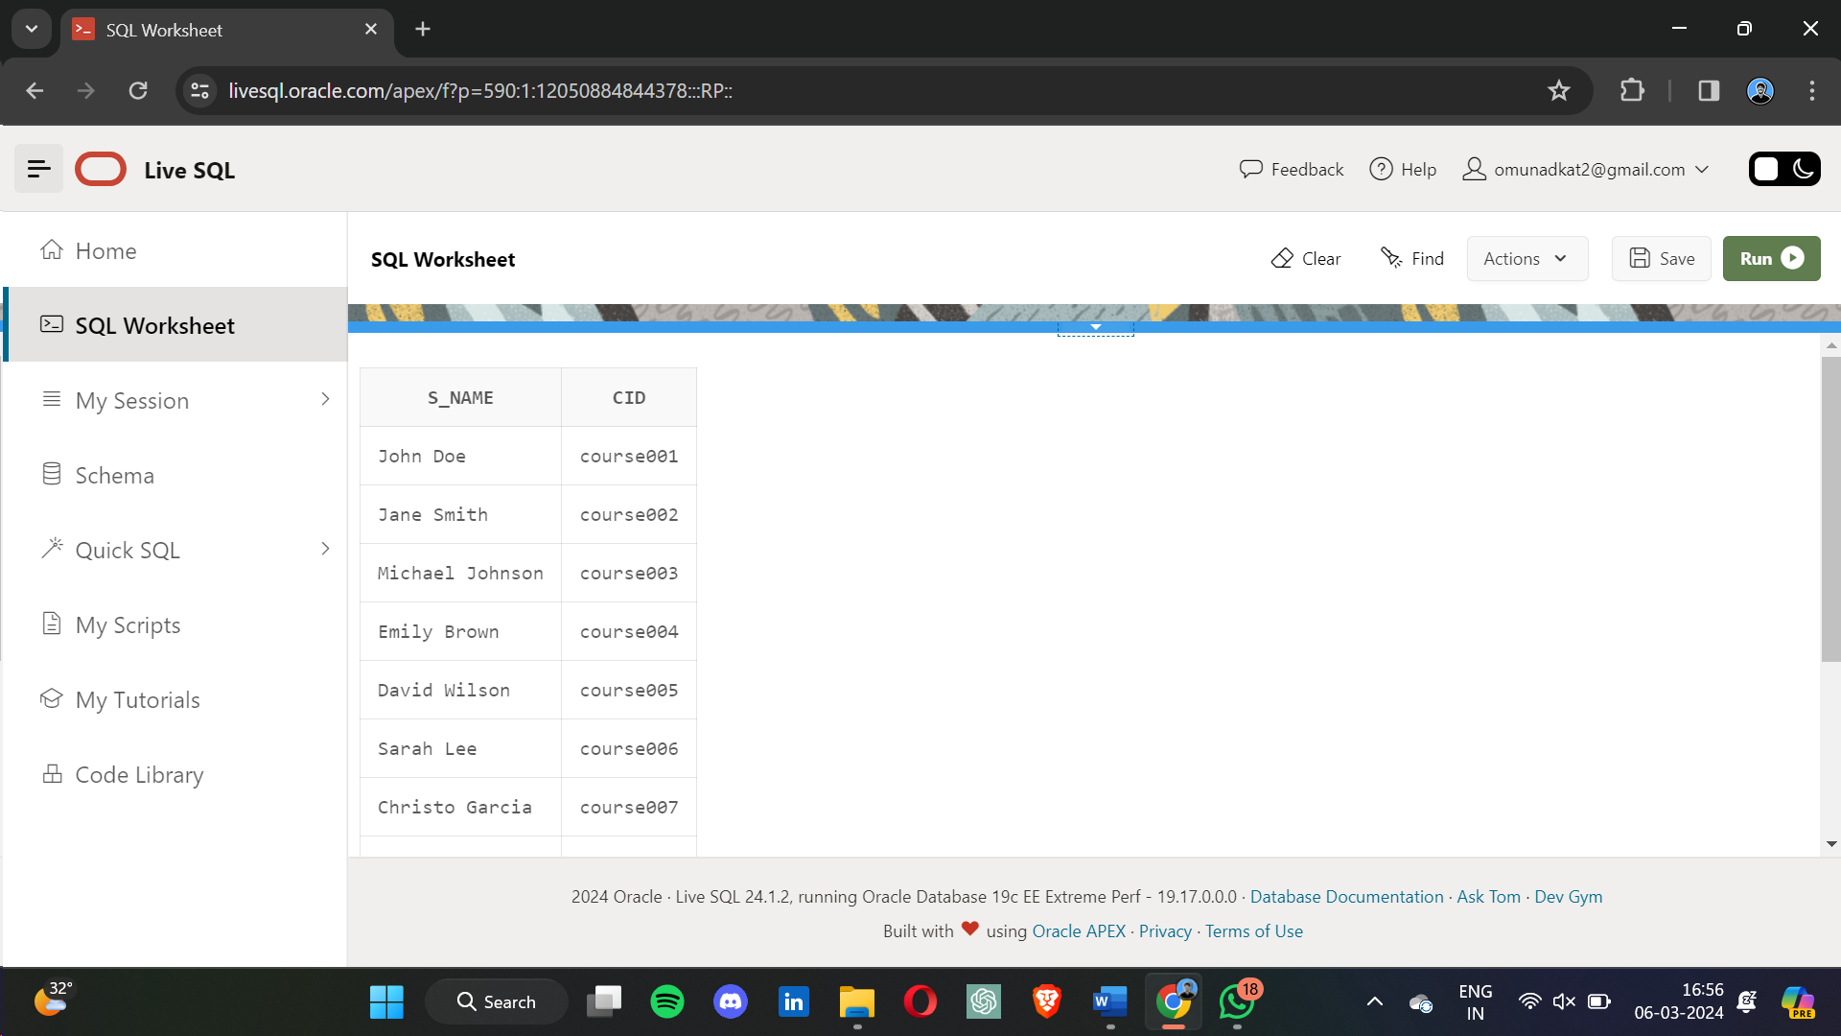 10. Subquery Example:**  
SELECT s_name FROM student WHERE sid IN (SELECT sid FROM results WHERE ob_marks > 90);

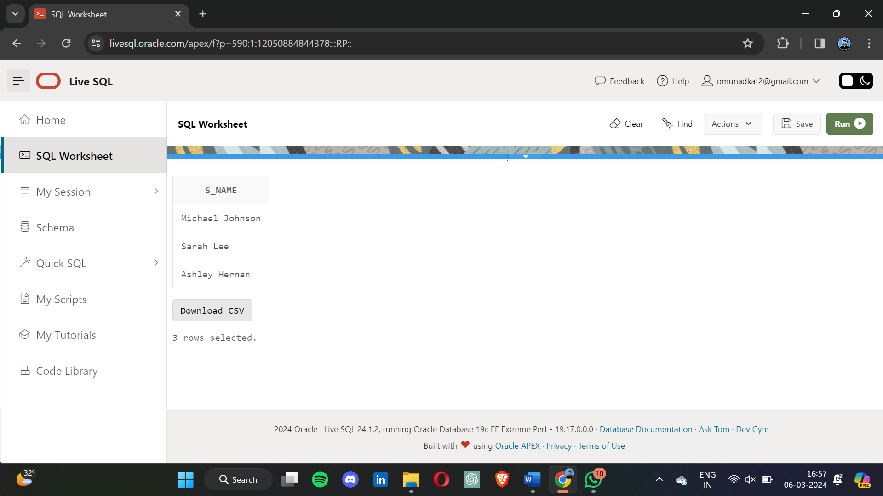 **11. Query with Aggregate Function:**  
SELECT MAX(amount) AS max_payment FROM payment;

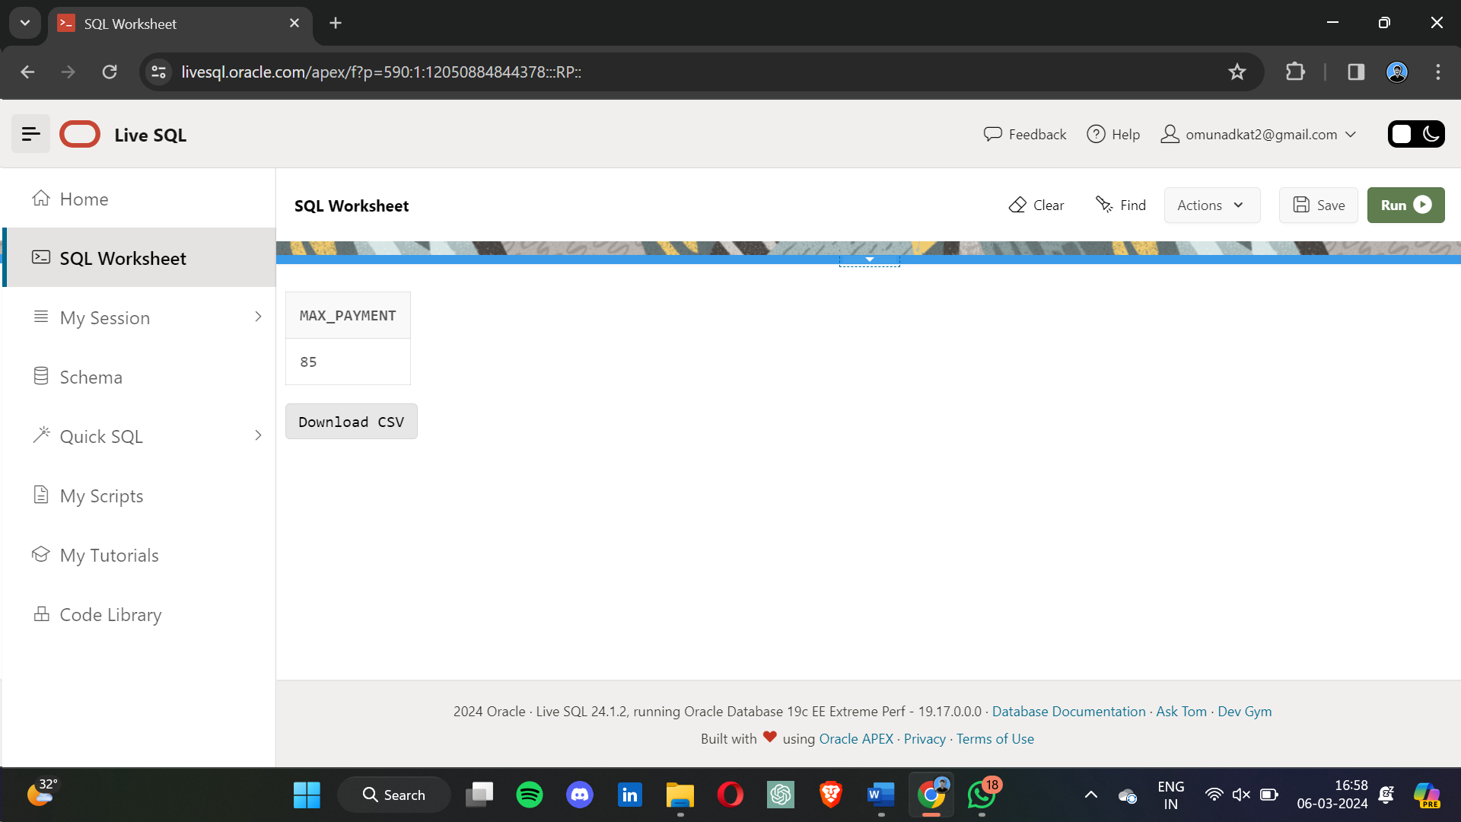 **12. Query with Scalar Function:**  
SELECT UPPER(s_name) AS upper_name FROM student;

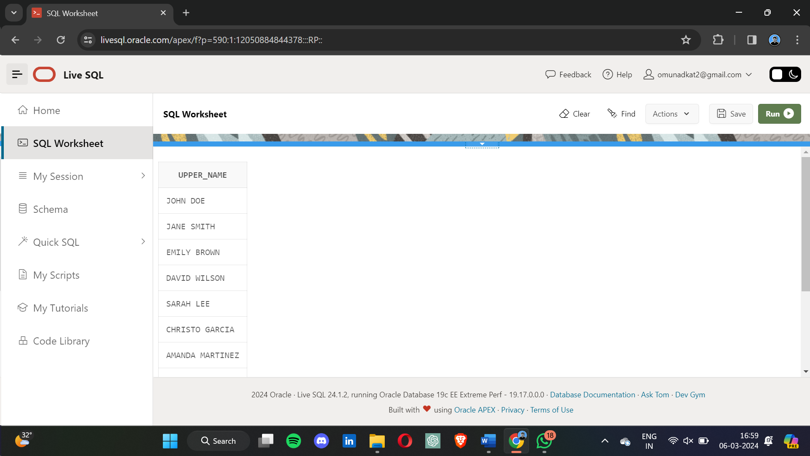

**13. Cursor Example:**DECLARE

v_sid student.sid%TYPE;

v_sname student.s_name%TYPE;

CURSOR student_cursor IS SELECT sid, s_name FROM student;

BEGIN

OPEN student_cursor;

LOOP

FETCH student_cursor INTO v_sid, v_sname;

EXIT WHEN student_cursor%NOTFOUND;

DBMS_OUTPUT.PUT_LINE('Student ID: ' || v_sid || ', Student Name: ' || v_sname);

END LOOP;

CLOSE student_cursor;

END;

* 1. 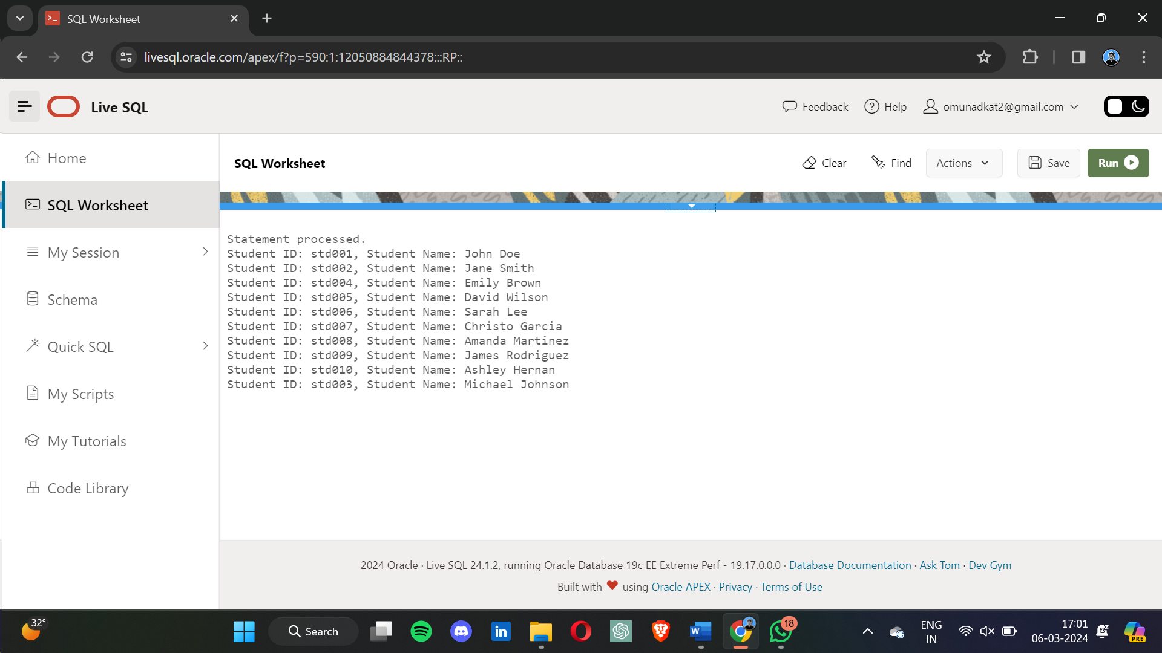 ***3 QUERIES GIVEN BY PROF SHJ :*  
      1) SELECT s_name**

**FROM STUDENT**

**WHERE sid IN (SELECT sid FROM PAID_COURSE);**

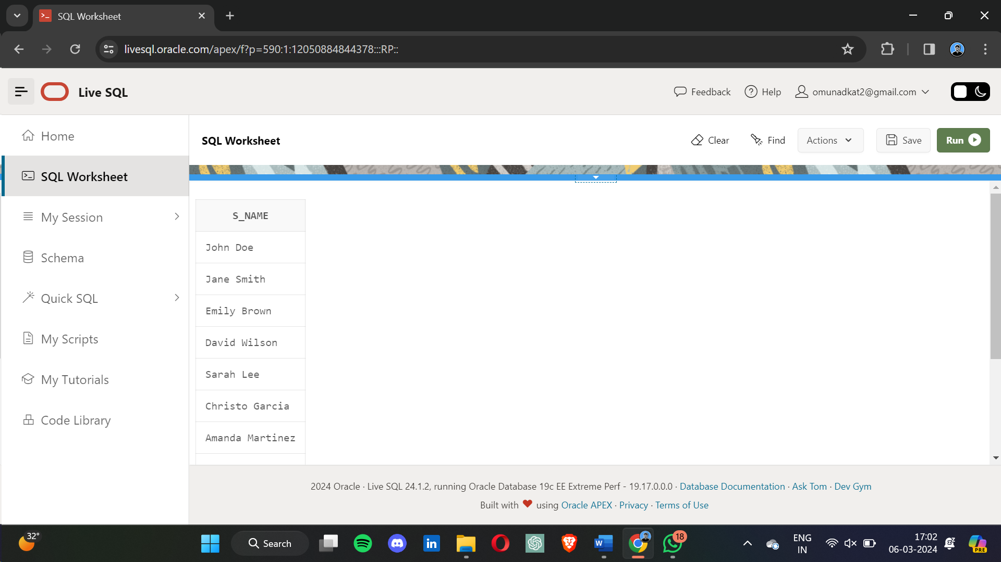 **2 ) SELECT sid, COUNT(DISTINCT cid) AS num_courses_enrolled**

**FROM COURSE**

**GROUP BY sid;** 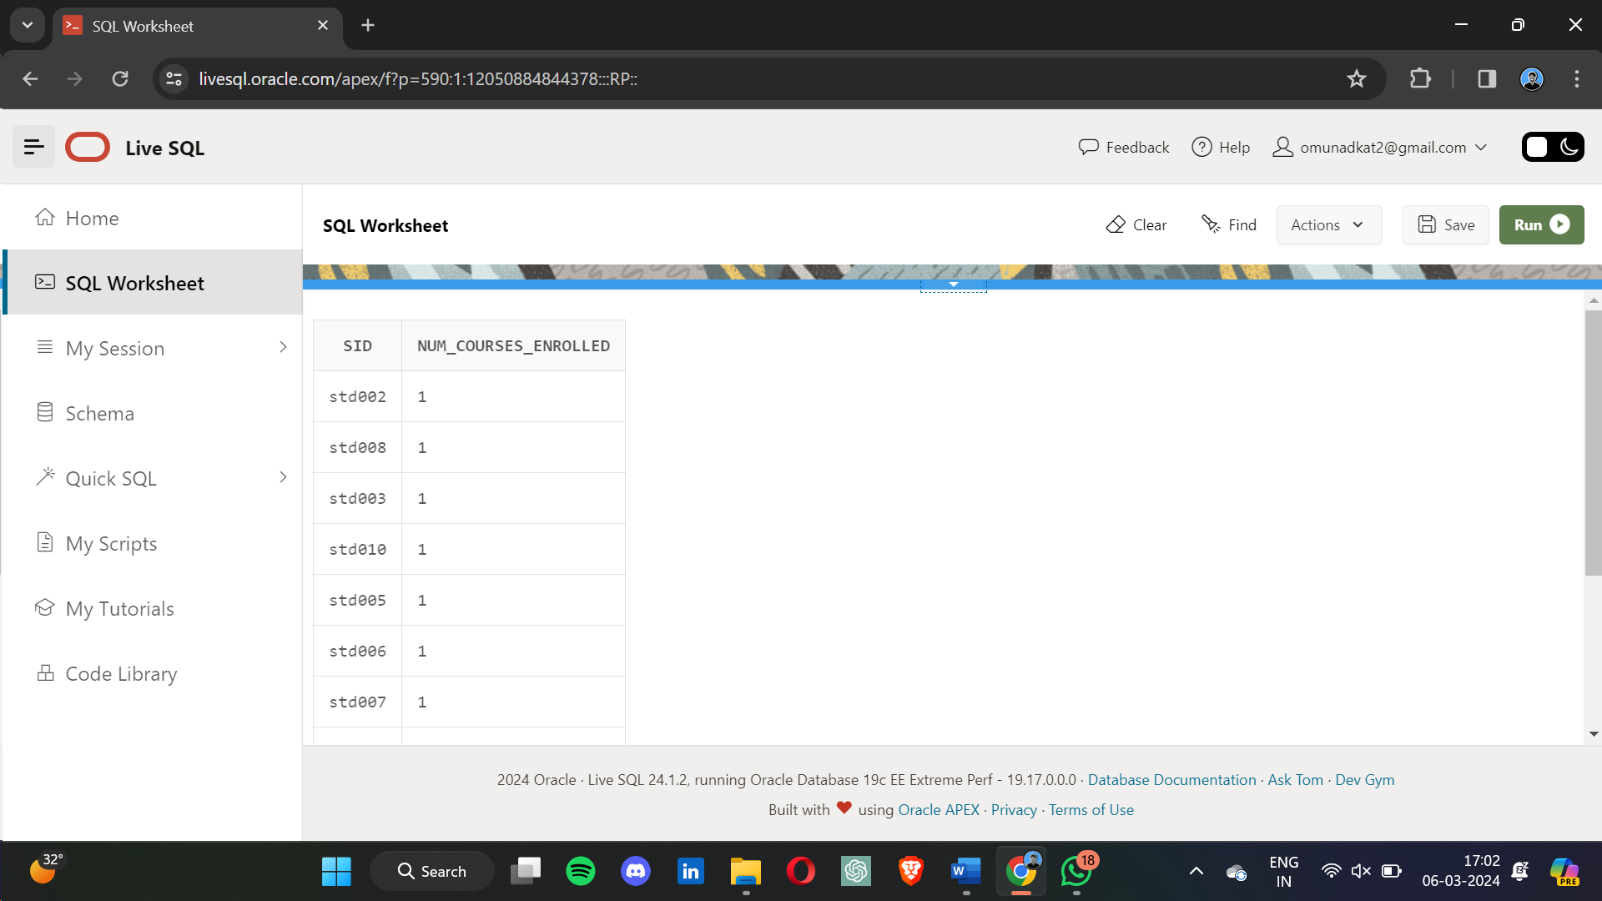  
  
**3) SELECT r.*, t.name AS test_name, c.cid AS course_id**

**FROM RESULTS r**

**INNER JOIN TEST t ON r.tid = t.tid**

**INNER JOIN COURSE c ON t.sid = c.sid;**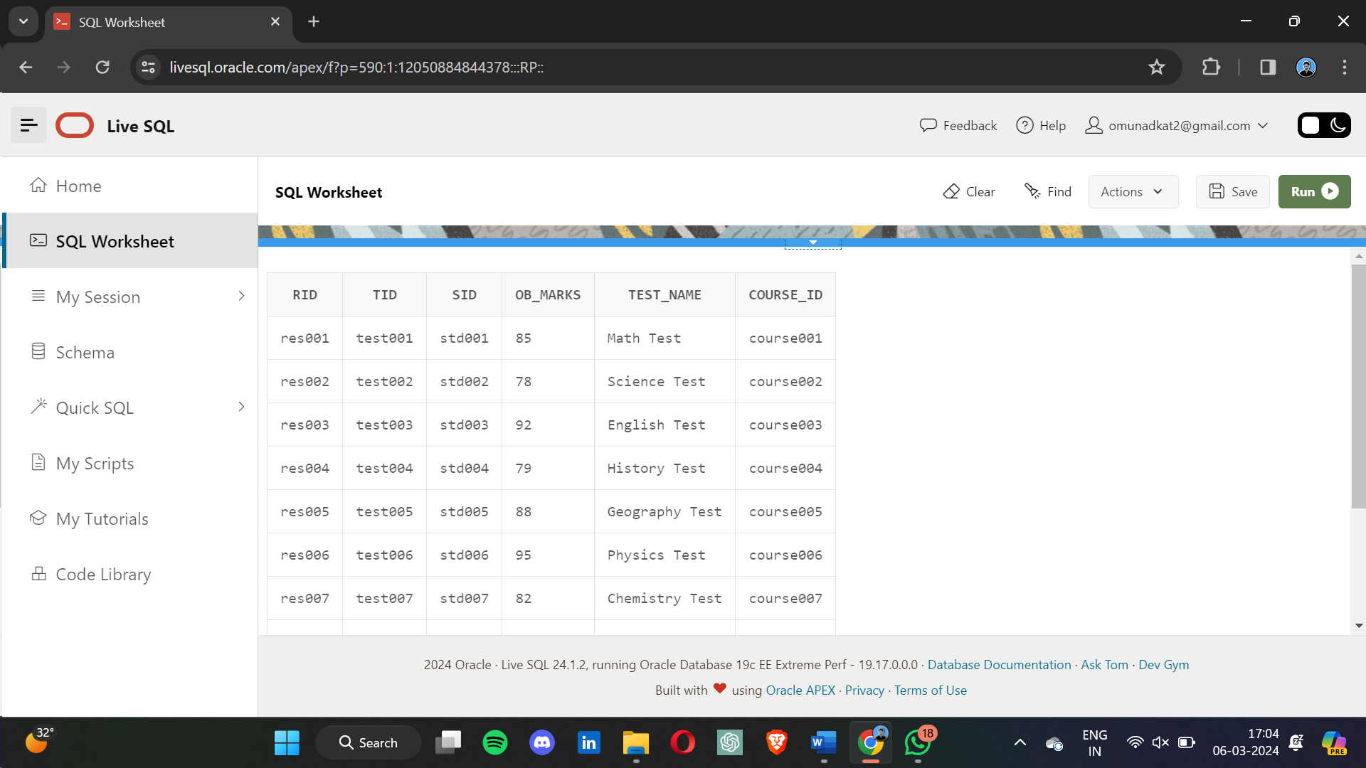

**TRIGGER QUIRIES :**

CREATE SEQUENCE CERTIFICATE_SEQ START WITH 1 INCREMENT BY 1;  
  
CREATE OR REPLACE TRIGGER generate_certificate_id

BEFORE INSERT ON certificate

FOR EACH ROW

BEGIN

SELECT 'CERT' || LPAD(to_char(CERTIFICATE_SEQ.NEXTVAL), 4,'0')

INTO :NEW.certi_id

FROM dual;

END;

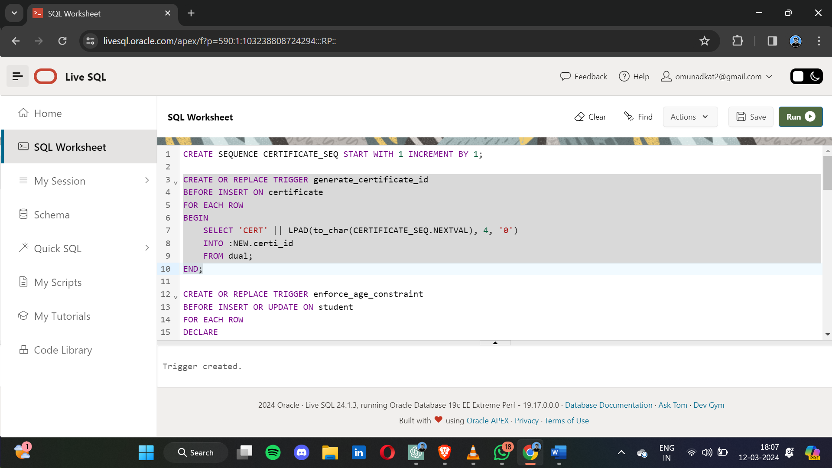

* 1. CREATE OR REPLACE TRIGGER enforce_age_constraint

BEFORE INSERT OR UPDATE ON student

FOR EACH ROW

DECLARE

current_date DATE := SYSDATE;

BEGIN

IF (MONTHS_BETWEEN(current_date, :NEW.sdob) / 12) < 18 THEN

RAISE_APPLICATION_ERROR(-20001, 'Student must be at least 18 years old.');

END IF;

END;  
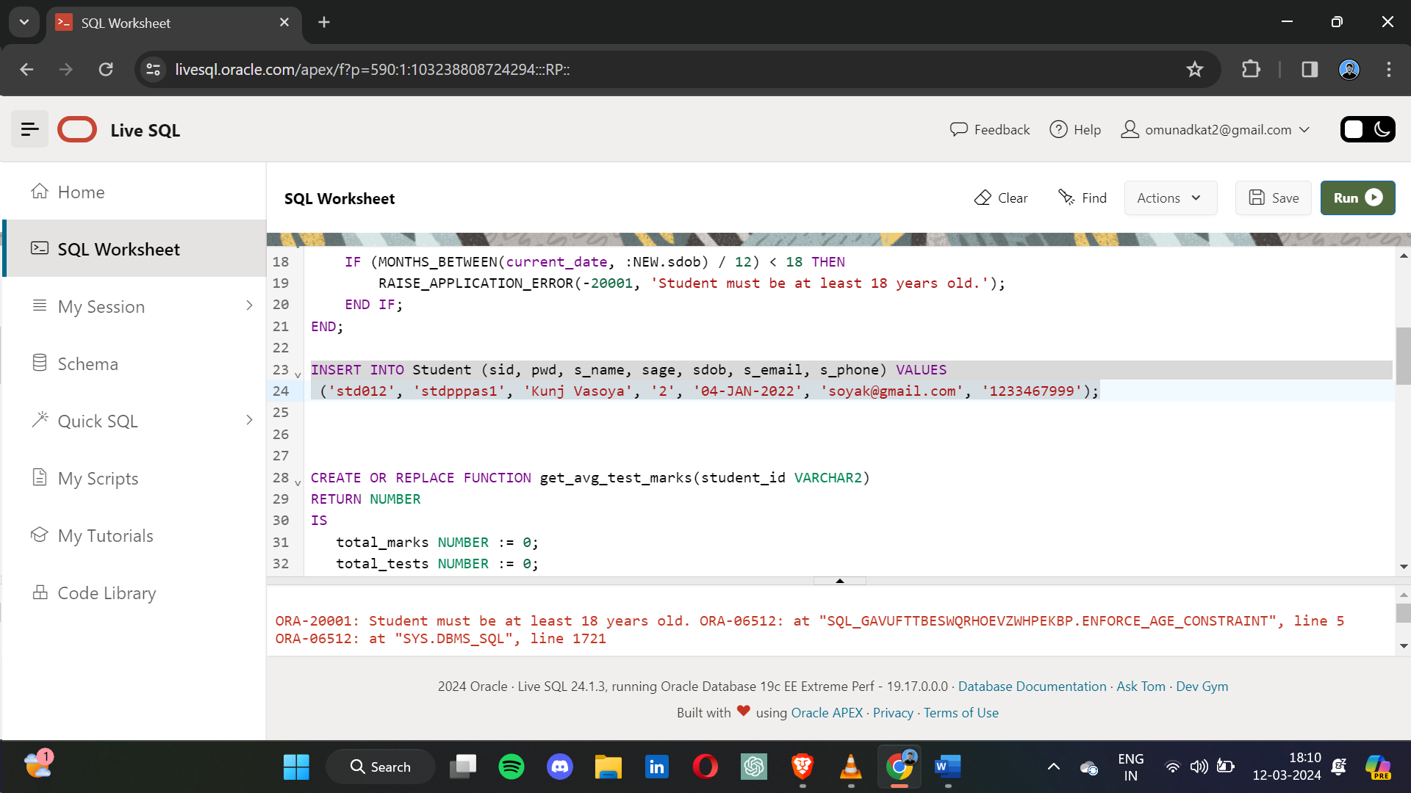

* 1. CREATE OR REPLACE FUNCTION get_avg_test_marks(student_id VARCHAR2)

RETURN NUMBER

IS

total_marks NUMBER := 0;

total_tests NUMBER := 0;

avg_marks NUMBER;

BEGIN

SELECT SUM(ob_marks), COUNT(*)

INTO total_marks, total_tests

FROM results

WHERE sid = student_id;

IF total_tests > 0 THEN

avg_marks := total_marks / total_tests;

RETURN avg_marks;

ELSE

RETURN NULL; -- Return NULL if no tests are found for the student

END IF;

END;  
SELECT get_avg_test_marks('std002') FROM dual;

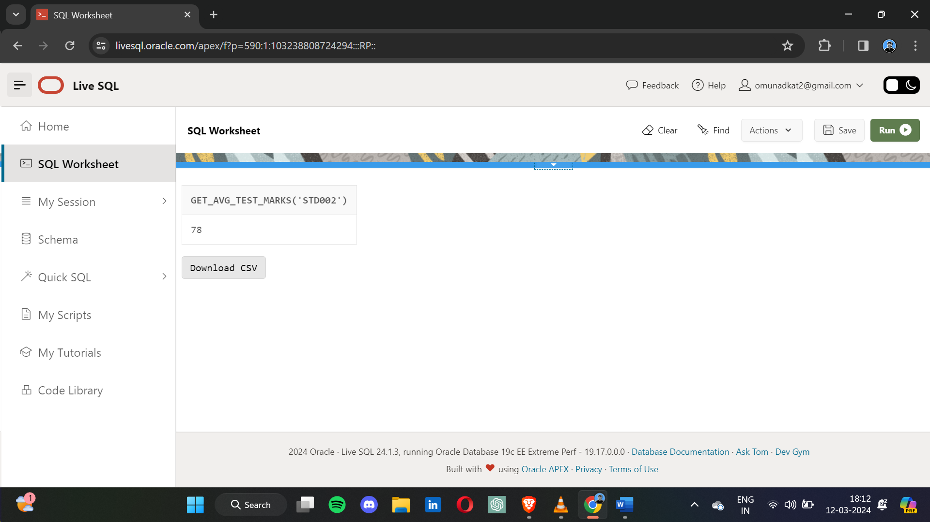

* 1. CREATE OR REPLACE FUNCTION get_latest_video_lecture(course_id VARCHAR2)

RETURN VARCHAR2

IS

latest_lecture VARCHAR2(10);

BEGIN

SELECT videoid

INTO latest_lecture

FROM videolec

WHERE cid = course_id

ORDER BY length_In_Hrs DESC

FETCH FIRST 1 ROW ONLY;

RETURN latest_lecture;

EXCEPTION

WHEN NO_DATA_FOUND THEN

RETURN NULL;

END;

SELECT get_latest_video_lecture('course004') FROM dual; 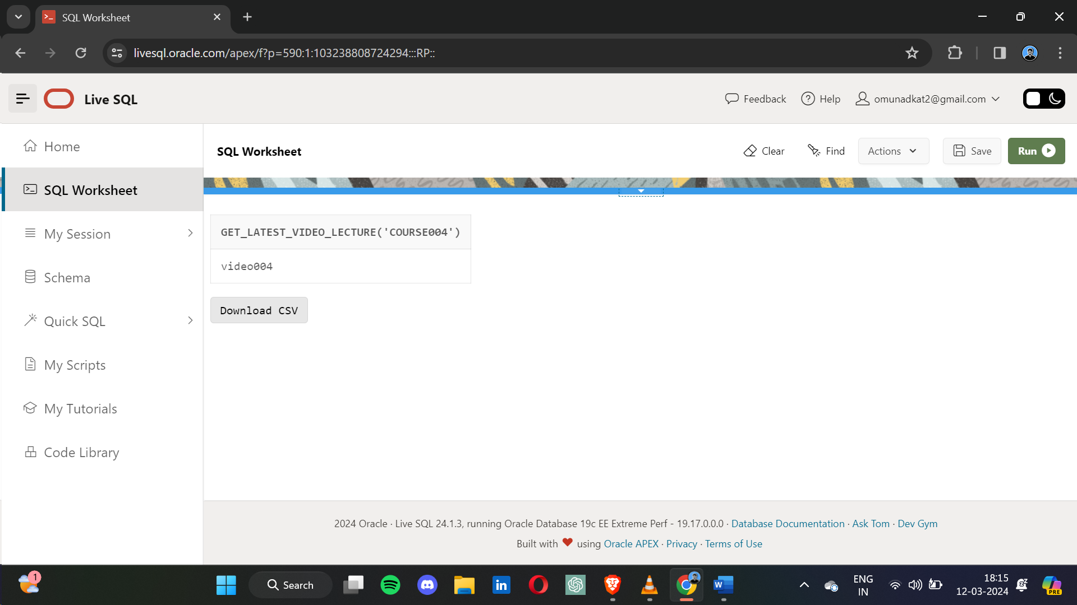

**it.**